NAME: ……………………………………………………………INDEX NO. ……………………

CANDIDATE’S SIGN. …………..... DATE:………………………………
OPENER EXAMS
TOP SCHOOLS MULTILATERAL 006
FORM 4 TERM 3
232/1
PHYSICS
PAPER 1
TIME: 2 HOURS
Kenya Certificate of Secondary Education

Answer all questions in the spaces provided.
Non programmable silent scientific calculators may be used

SECTION A 25 MARKS (ANSWER ALL QUESTIONS)

- Water is normally used as a coolant in many internal combustion systems. Explain why (2mks)

- Give the reading indicated in the section of the Vernier calipers shown below (2mks)
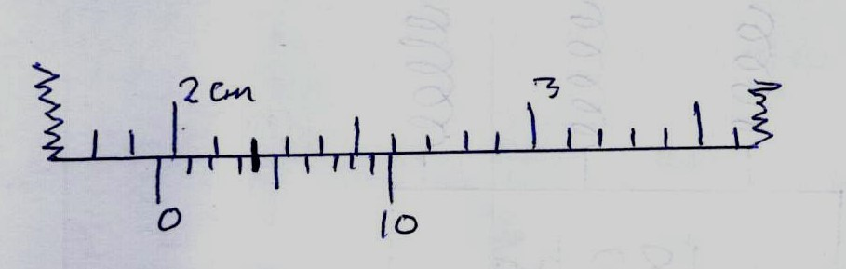
- One advantage of friction force is that it enables motion. State one disadvantage of friction (1mk)

- Steel bars are used to reinforce concrete beams. Give a reason why (2mks)

- A stone of mass 50g is whirled in a vertical circle at a linear speed of 25m/s when attached to a string of length 0.5m. Calculate the tension on the string when the stone is at the bottom of the circular path. [g=10N/kg](3mks)

- An inflated balloon is left on the sun for some time. The balloon burst, give a reason why it bursts. (2mks)

- Name two factors that determine momentum of a body. (2mks)

- It is common practice by motor vehicle body builders to make luggage compartments of buses underneath passengers’ seats. How does this enhance safety of those travelling in such buses? (2mks)

- An empty density bottle has a mass of 20g. When full of water, its mass is 70g and when full of a liquid X, its mass is 55g. Given that density of water is 1000kg/m³, find the density of liquid X. (3mks)

- Figure below shows a system used to transfer a liquid from a tank A to tank B on earth’s surface.
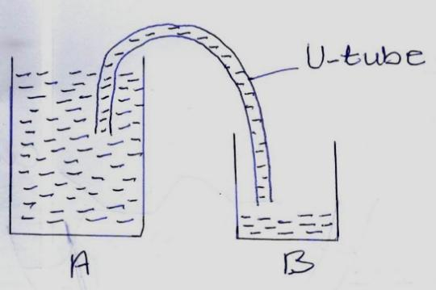
(a). Give the name of this method (1mk)
(b). When some young astronauts tried the method on the moon’s surface, they failed. Give a reason why they were unsuccessful (1mk)

- What is the SI unit of specific heat capacity (1mk)

- An object of mass 90kg weighs 360N on the surface of a certain planet. Find the acceleration due to gravity of this planet (3mks)

SECTION B (55 MARKS) ANSWER ALL QUESTIONS
- (a). State Hooke’s law (1mk)

(b). State three factors that affect spring constant (3mks)

©.A spring has a spring constant of 40N/cm. 3 such springs are used to suspend a mass of 180kg as shown in the figure below.
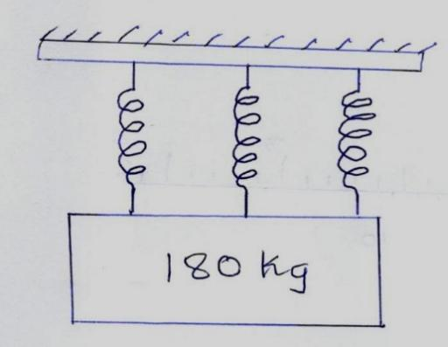
Find the extension of the system (3mks)
(d). A spring of elastic constant 50N/cm is compressed 2cm inside the muzzle of a shotgun. If the gun is to shoot a bullet of mass 20g when trigger is released. Find;
- The initial velocity of the bullet as it leaves the gun (4mk)

- The recoil velocity of the gun if it has a mass of 4kg. (3 decimal places) (3mks)

- (a). What is an ideal gas (1mk)

(b). Absolute zero temperature is practically not attainable. Explain why (1mk)

©. A gas has a volume of 2m³ at 25˚C. What will be the volume of the gas at a temperature of 77˚C keeping pressure constant (2.d.p) (3mks)

(d). A hot air balloon is sometimes used by merry makers to rise to high heights. Explain how it works (3mks)

(e). Figure below represents a cross-section of a large ship.
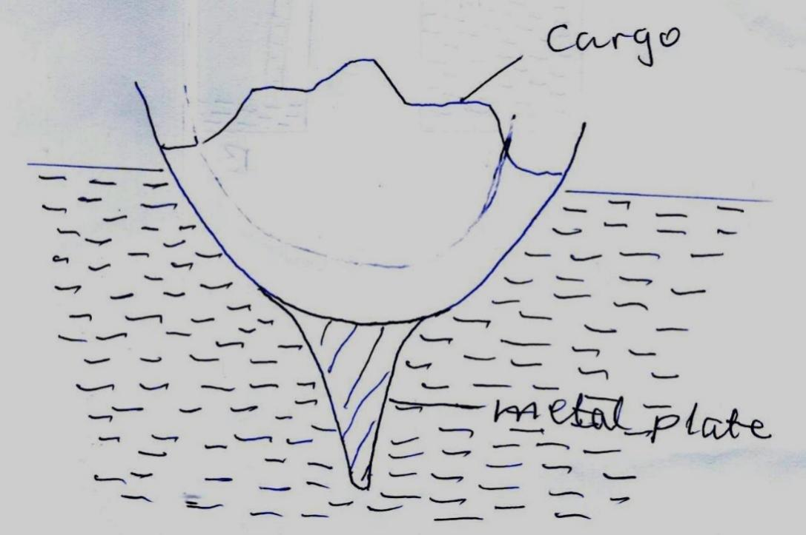
- What is the use of the large metal plate underneath the ship (2mks)
- The ship can carry heavier luggage in sea-water than in fresh water. Explain (2mks)

- A loaded ship whose total weight is 4000 tonnes is moving in sea water of density 1030Kg/m³. Find the volume of ship under the water surface (1.d.p) (3mks)

- (a). Define the term velocity ratio of a machine (1mk)

(b). Figure below shows part of a hydraulic press. The plunger is the piston where effort is applied while the Ram piston is the piston where the load is applied. The plunger has a cross-sectional area a m²while Ram piston has a cross-section area, A m².
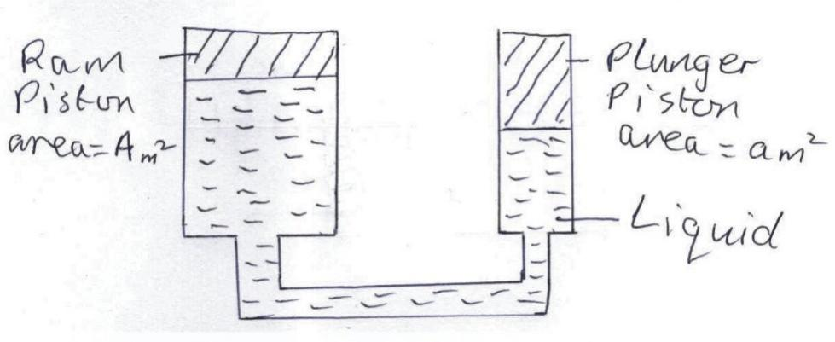
When the plunger moves down a distance d the Ram moves up a distance D. Derive an expression for the velocity ratio (V.R.) in terms of A and a . (4mks)

©. A machine of velocity ratio 45 overcomes a load of $4.5×{10}^{3}N$ when an effort of 135N is applied. Determine
- The mechanical advantage (M.A) of the machine (2mks)

- Efficiency of the machine (2mks)

- The percentage of work that goes to waste (1mk)

(d). State two properties of fluid suitable for use in such a hydraulic machine (2mks)

- (a). Define the term specific latent heat of fusion (1mk)

(b). You are provided with the apparatus shown in the figure below. Describe an experiment to determine the specific latent heat of steam L using the set up. In your answer clearly explain the measurements to be made and how these measurements could be used to determine L (6mks)
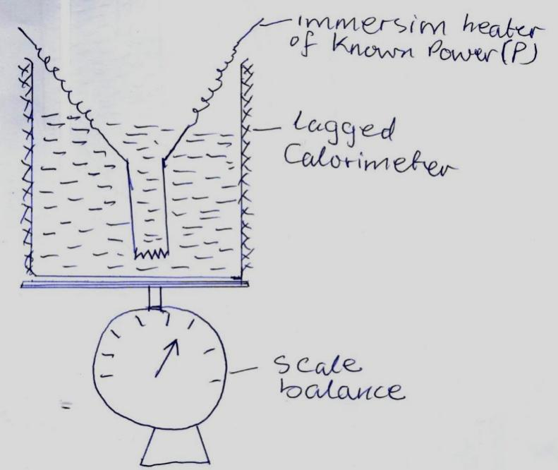
©. A block of metal of mass 150g at 100˚C is dropped into a lagged calorimeter of heat capacity 40JK⁻¹ containing 100g of water at 25˚C. The temperature of the resulting mixture is 34˚C. (Specific heat capacity of water =4200JKg⁻¹K⁻¹). Determine:
- Heat gained by calorimeter (2mks)

- Heat gained by water (2mk)

- Heat lost by the metal block (1mk)

- Specific heat capacity of the metal block (2mks)

