Name: ……………………………………………………................. adm No. ………………..

School: …………………………………………………. Candidate’s Signature………………

Date: ………………

OPENER EXAMS
TOP SCHOOLS MULTILATERAL 006
FORM 4 TERM 3
232/3
PHYSICS
PAPER 3
(PRACTICAL)
TIME: 2 ½ HOURS
Kenya Certificate of Secondary Education
INSTRUCTIONS TO CANDIDATES:-
- Write your name and Adm number and school in the spaces provided above.
- Answer all the questions in the spaces provided in the question paper
- You are supposed to spend the first 15 minutes of 2 ½ hours reading the whole paper carefully before commencing your work.
- Marks are given for a clear record of the observations actually made, their suitability, accuracy and the use of them
- Record your observations as soon as you make them.
- Mathematical tables, slide rules and silent non-programmable electronic calculators may be used.
- Take g = 10ms⁻²
For Examiners’ Use Only:
QUESTION | MAXIMUM SCORE | CANDIDATE SCORE
1 | 20
2 | 20
TOTAL SCORE | 40

This paper consists of 9 printed pages. Candidates should check to ascertain that all pages are printed as indicated and that no question is missing

Question 1
You are provided with the following
- A voltmeter 0-2.5 or 0-5 V
- A center zero galvanometer
- An ammeter
- Two new size D dry cells
- Two cell holders
- A switch
- Eight connecting wires each with a crocodile clip on one end
- A coiled resistance wire labeled X
- A resistance wire labeled AB mounted on a millimeter scale
- Six 10 carbon resistors
- A jockey/crocodile
Proceed as follows
- Set up the circuit with the cells in parallel as shown in the figure below
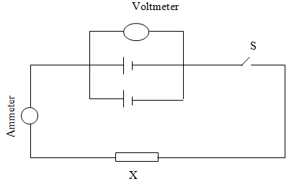
V
A

(b) With the switch open, record the reading E of the voltmeter
E = _____________________________ (1mark)
(c)Close the switch and record the current I flowing through the circuit and the potential difference V across the cells
I = _____________________________________ (1mark)

V = ___________________________________ (1mark)

d) Given that E = V + Ir and V = IR, determine the internal resistance r of the combined cells and the resistance (R) of the wire labeled X (3marks)

(e) Now set up the circuit as shown in the figure below. Z is one of the 10 carbon resistors.
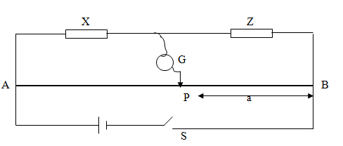

(f) Close the switch. Tap the jockey at various points along the wire AB and locate a point P at which the galvanometer shows zero deflection. Measure and record in the table below the length ‘a’ where a = PB
(g) Repeat the procedure in (f) using two resistors in parallel, three resistors in parallel, four resistors in parallel, five resistors in parallel, and six resistors in parallel. Record your readings in the table below. R is the effective resistance for the PARALLEL combination.

Number of 10Ω resistors | One | Two | Three | Four | Five | Six
Effective resistance (R)
length (a) in cm
¹/_{R}(Ω⁻¹)
¹/_{a} (cm⁻¹)
(5marks)

(h) Plot a graph of ^{I}/_{a} (y-axis) against ^{I}/_{R} (5marks)
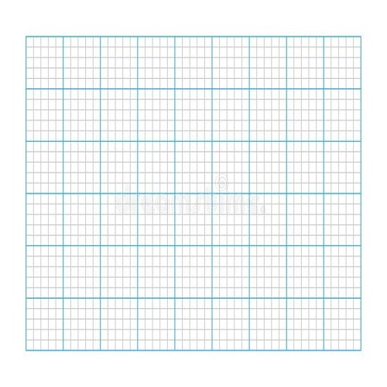
- Determine the slope S, of the graph (2marks)

(j) Given that I / a = β / kR + 1 / k, where k = 100cm, Use the graph to determine β
(2marks)

Question 2
PART A
- You are provided with the following apparatus.
- A 50ml measuring cylinder
- A test tube
- About 200ml of Water in a 250ml beaker
- Six 1g ball bearings
- A vernier caliper
- Half meter rule
- Label
Procedure
- i) Measure the internal diameter of the measuring cylinder using a vernier caliper.
D = ________________________________ cm (1 mark)
ii) Calculate the area A of cross section of the inner part of the cylinder. (2 marks)

- i) Pour water into the measuring cylinder up to 50ml mark. Mark this point as h₁ using the label.
ii) Place the test tube upright inside the measuring cylinder so that it floats. Measure the increase in height of the water level from h₁ using a half meter rule. Record this value in the table below.
(i) Cylinder
without test tube
(ii) Test tube
with ball
bearings
(ii) Test tube
without ball
bearings

(iii)Insert one ball bearing into the test tube then place the test tube back into the cylinder gently. NB (Remove the test tube slant it slightly and let the ball bearing roll to the bottom. Dropping the ball can break the test tube) measure the increase in height from h₁
- i) Repeat the procedure in b(iii) above by adding ball bearings one by one each time measuring the new change in height H from h₁. Enter the results in the table shown. (3 marks)
Mass of ball (g) | 0 | 1 | 2 | 3 | 4 | 5 | 6
Change in height (H) (cm)

- Determine the weight of the water displaced W_{w} when the test tube has six ball bearings (density of water is 1 g/cm³) ( 3mks)

- Determine the weight W_{o} of the test tube when empty given that
W_{w} = W_{o} + 0.06. (2 marks)

- State any one source of error in the experiment above (1mark)

PART B
You are provided with the following:
- A bare copper wire with a loop on one end labeled W
- A retort stand, boss and clamp
- An optical pin mounted on a cork
- A stop watch
- A micrometer screw gauge to be shared
Proceed as follows:
- Clamp the cork so that optical pin is horizontal. Hang the copper wire from the pin by the loop as shown in the figure below. Ensure the wire is straight and the length X between the lower tip and the optical pin is 20 cm.
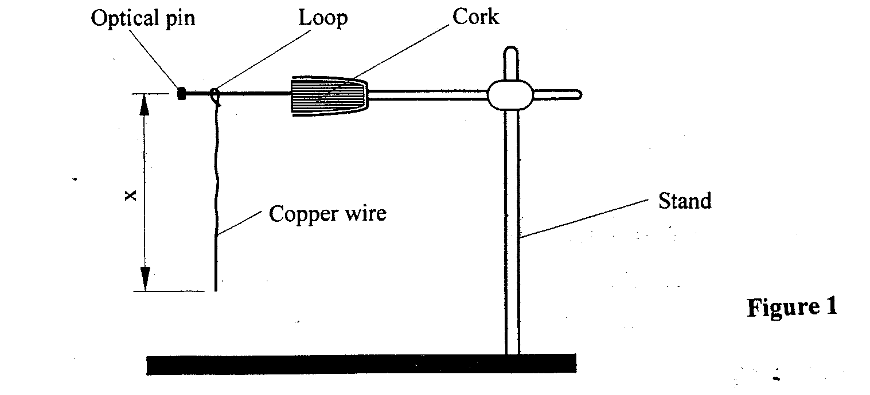
- Displace the lower tip of the wire slightly and then release it. Measure the time t for 10 oscillations of the wire and record the value in the table below.

- Repeat the procedure in (b) above for two more trials each time recording the time taken in the table below.
3 marks

TRIALS | 1 | 2 | 3
Time t for 10 oscillations (s)
Period T (s)
T² (S²)

- i) Determine the average of T² to 4sf 1mark

(ii) Using a micrometer screw gauge, measure the diameter D of the wire in SI units (1mark)

ii) Obtain the value of K in the equation T²= $\frac{8π}{3KD}$ (2marks)

