OPENER EXAMS
TOP SCHOOLS MULTILATERAL 006
FORM 4 TERM 3
Kenya Certificate of Secondary Education
451/2 PAPER 2
COMPUTER STUDIES
(Practical)
THE KENYA CERTIFICATE OF SECONDARY EDUCATION (K.C.S.E)
Name……………………………………………Index(ADM ) No………………class……
Candidates Signature…………………Date ………………………………..
451/2
COMPUTER STUDIES
PAPER 2
2 ½ HOURS
INSTRUCTIONS TO CANDIDATES
- Type your name and index number at the top right-hand corner of each print out.
- Write your name and index number on the CD-R/ CD-RW provided.
- Write the name and version of the software used in each question attempted in the printouts used.
- Answer all the questions.
- All questions carry equal marks.
- Passwords should not be used when saving files.
- All files must be transferred to the CD-R/ CD-RW.
- Make printouts of your answers on the papers provided for printing.
- Arrange your printouts and tie/ staple them together.
- Hand in all the printouts and the CD/removable storage medium provided.
- This paper consists of 5 printed papers.
- Candidates should check the question paper to ascertain that all pages are printed as indicated and no questions are missing.
- Candidates must answer the questions in English.

- Open a word processing program and type the document below as it appears and save it as CBC. (15 marks)
PARENT’S ROLES IN COMPETENCY BASED CURRICULUM
Kenya has embraced a Competency Based Curriculum (CBC) to increase skills development and instill values in the learner. Parental empowerment and engagement in the learning process is essential to the learner’s growth and development. As a parent, you are the first educator, trainer and source of authority for your child. The purpose of this brochure, therefore, is to give you more information about CBC and your role in the learning process of your child.
WHAT IS COMPETENCY BASED CURRICULUM?
This is a process that gives learners an opportunity to be actively involved in learning. It facilitates identification and development of learner’s unique talents and abilities through different career pathways after grade 9. CBC assists learners acquire, nurture and apply values in day to day living
WHY THE CHANGE FROM 8-4-4 CURRICULUM TO CBC?
The Competency Based Curriculum was rolled out nationally in January 2019 in Early Years Education. The difference between 8.4.4 and CBC;
From 8-4-4 | To CBC
Focuses on teaching | Focuses on practical learning
Focuses on memorization of content | Focuses on application of knowledge
Focuses on academic achievement | Focuses not only on academic achievement but also on skills development and nurturing of values
Focuses on examination and results | Focuses on what the learner is expected to achieve and provision of feedback on the learner’s progress
Focuses on competition | Focuses on collaboration
Not all learners transited to the next level | Facilitates smooth transition for all learners
Less emphasis on talent and career progression | More emphasis on talent identification and career development
Less parental engagement in learning | More parental empowerment and engagement
GENERAL ROLES OF THE PARENT IN COMPETENCY BASED CURRICULUM

The following are general roles to support the learning of your child in CBC

- Provide basic necessities.
- Protect your child from physical and emotional harm.
- Instill and nurture morals and values.
- Teach and guide children to make the right choices and make them aware of consequences.
- Teach and model proper use of resources.
- Instill a sense of responsibility by ensuring children participate in age-appropriate chores.
- Help in enhancing learning achievements in your child as guided by the teacher.
- Engage with the teacher to enrich your child’s learning experiences.
- Provide tender, loving care to boost your child’s emotional safety and a sense of belonging.
- Take part in school activities such as academic clinics, talent

Required
  - Set page margins as follows:
    - Left margin: 6 Picas (2 marks)
    - Right, Top and Bottom margins: 3 Picas (2 marks)
  - Apply 1.5 line spacing on the entire document (2 marks)
  - Insert an in margin drop cap on paragraph 1 dropped to 4 lines (2 marks)
  - Save the document as CBC-1 (2 marks)
  - Print out the following:
    - CBC (2 marks)
    - CBC-1 (2 marks)
- The following is an extract from Wavumbuzi Entrepreneurship Challenge showing the performance of different participants over the Six-week period.
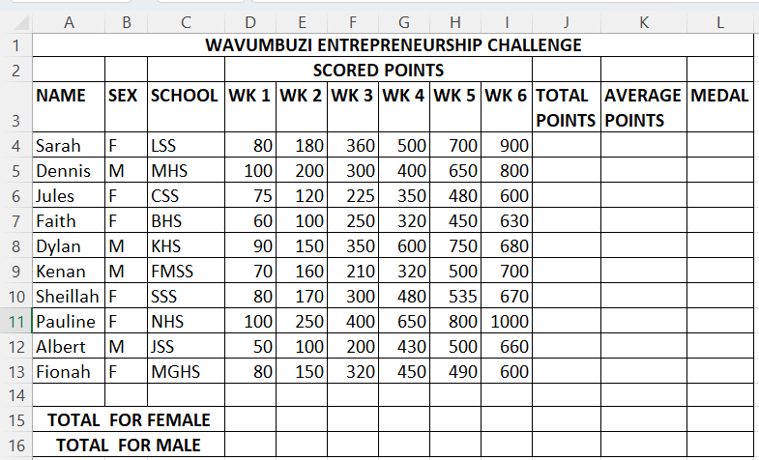
    - Using a spreadsheet package, enter the above information and save it as Wavumbuzi Challenge (11 marks)
    - Format the worksheet to appear as it is (4 marks)
    - Rename the worksheet containing the data as Wavumbuzi-1 (1mark)
    - Copy the contents of Wavumbuzi-1 to another worksheet and rename it as Wavumbuzi-2 (2 marks)
  - Type a formula at:
    - Cell J4 to compute the total points for Sarah (2 marks)
    - Apply the formula to the appropriate cells (1 mark)
  - Type a function at:
    - Cell K7 to compute the Average Points for Faith. (2 marks)
    - Apply the function to the appropriate cells. (1 mark)

  - A participant earns a medal based on the Average Points scored as follows:
Average points | Medal
500 and above | Gold
300-499 | Silver
Below 300 | Bronze
    - Type a formula in L5 to determine David’s medal (3 marks)
    - Apply the formula to other appropriate cells (2 marks)
  - Insert a blank column after average points and label it RANK. Using appropriate function, compute the rank of the participants based on the average points in descending order (5 marks)
  - (i) Using appropriate functions, compute the:
        - Total points for the female per week in cell D15 (2 marks)
        - Total points for the male per week in cell D16 (2 marks)
    - Apply the functions to the appropriate cells (2 marks)
  - Using Wavumbuzi-1 worksheet, create a bar chart showing how various participants performed in the six-week challenge and Move it to a new worksheet: (7 marks)
    - Insert the Chart Title as: WAVUMBUZI SIX WEEK CHALLENGE PERFORMANCE
    - Insert X-axis as: PERFORMANCE SCORES
    - Insert Y-axis as: PARTICIPANT NAME
    - Display the legend at the bottom
    - Rename the worksheet containing the chart to WavumbuziChart
  - Print out each of the following: (3 marks)
    - Wavumbuzi -1
    - Wavumbuzi-2 (showing the formulas)
    - WavumbuziChart

