OPENER EXAMS
TOP SCHOOLS MULTILATERAL 006
FORM 4 TERM 3
Kenya Certificate of Secondary Education
231/3
BIOLOGY
PAPER 3
(PRACTICAL)
1HR 45 MINUTES
NAME…..……………………………………… INDEX NO…………… SIGN………..
INSTRUCTIONS TO CANDIDATES
- Write your name and Index Number and sign in the spaces provided above.
- Answer ALL questions in the spaces provided in the question paper.
- You are NOT allowed to start working with the apparatus for the first 15 minutes of the 1³/₄ hours allowed for this paper. This time is to enable you to read the question paper and make sure you have all the chemicals and apparatus that you may need.
- All workings MUST be clearly shown where necessary.
- Mathematical tables and silent electronic calculators may be used.

For Examiners use only.
Question | Maximum Score | Candidates Score
1 | 12
2 | 14
3 | 14
TOTAL SCORE | 40

This paper consists of 5 Printed pages.
Candidates should check the question paper to ensure that all the papers are printed as indicated and no questions are missing.

1. The photograph below shows the arrangements of different type of cells and tissues in a certain living organism. Study it and answer the questions that follow.

a) i) From what part of the plant was the photograph obtained. (1 mark)
.......................................................................................................................................................................
ii) Name the parts labeled. (3marks)
P ...................................................................................................................................................
Q ...................................................................................................................................................
R ...................................................................................................................................................
S ...................................................................................................................................................
T ...................................................................................................................................................
b. i) State the function of the part labeled Q. (1mark)
.......................................................................................................................................................................
ii) State two adaptations of structure Q to its function. (2 marks)
................................................................................................................................................................................................................................................................................................................................................
c. State two environmental factors which regulate the function of the part labeled P. (2 marks)
................................................................................................................................................................................................................................................................................................................................................
d. Measure the length of one cell of region labeled Q on the photomicrograph whose magnification is X5000.What is the actual length of the cell in micrometer? Show your working. (3marks)
................................................................................................................................................................................................................................................................................................................................................ ........................................................................................................................................................................

2. You are provided with solution labeled L and K.
a) Use the reagents provided to determine their identity. Record your procedure, observation and conclusion in the table below. (6 marks)

Food substance | procedure | observation | conclusion
b. Tie one end of the visking tubing provided tightly. Put solution K in the visking tubing and tie the open end. Imerse the visking tubing in the beaker containing solution L .Let the set up stand for about 30 minutes.
i) Test the contents in the visking tubing with iodine and benedict’s solution. Record your procedure,observation and conclusion in the table below. (3marks)
Test with | procedure | observation | conclusion
Iodine solution
Benedict’s solution
ii) Test the contents in the beaker with iodine and Benedict’s solution. Record your procedure, observation and conclusion in the table below.
Test with | procedure | observation | conclusion
Iodine solution
Benedict’s solution

c. Account for your observation in b(i) and (ii) above. (4mks)
................................................................................................................................................................................................................................................................................................................................................ ................................................................................................................................................................................................................................................................................................................................................ ...............................................................................................................................................................................................................................................................................................................................................
d. What does a visking tubing equite to in a living organism?

3. Study the organisms drawn below and answer the questions that follow.
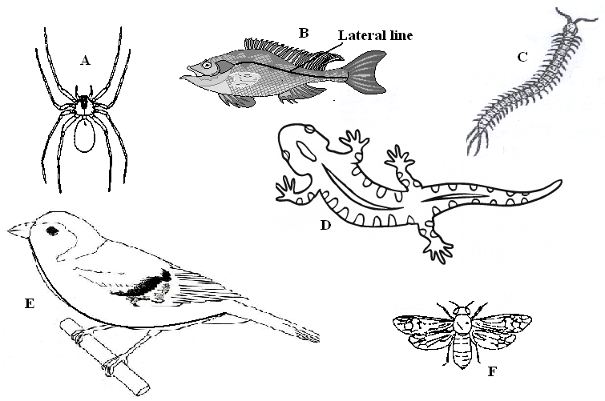

- Use the dichotomous key below to identify the class the organisms belong to. (12 marks)
- (a) Phylum Chordata ……………………………………………………… go to 2
- Phylum Arthropoda ……………………………………………………. go to 3
- (a) Has scales on the body ………………………………………………… go to 4
(b) Has no scales on the body …………………………………………..… Mammalia
3. (a) Has cephalothorax ……………………………………………….……. Arachnida
(b) Has no cephalothorax …………………………………………………. go to 5
4. (a) Has fins ………………………………………………………………… Pisces
(b) Has no fins ……………………………………………………………... go to 7
5. (a) Has three pairs of legs …………………………………………………. Insecta
(b) Has more than three pairs of legs ……………………………………… go to 6
6. (a) Two pairs of legs per segment ………………………………………… Diplopoda
(b) One pairs of legs per segment …………………………………………. Chilopoda
7. (a) Has feathers ……………………………………………………………. Aves
(b) Has no feathers ………………………………………………………… go to 8
8. (a) Has a tail ……………………………………………………………….. Reptilia
(b) Has no tail …………………………………………………………….. Amphibia
Specimen | Step followed | Identity
A
B
C
D
E
F

(b) Name the type of reproduction shown by specimen B and state it disadvantage. (2marks)
…………………………………………………………………………………………………………………………………………………………………………………………………………………………………………………………………………………………………………………………………………………………………………………………………………………………………………

