

Name: ________________________________ School: _____________

Class: ______Admission Number: ______/ Index Number: ___________

Date: ___________
312/2
GEOGRAPHY PAPER 2
SEPTEMBER, 2025

TIME: 2 HRS 45 MINS

MIDGEA GEOGRAPHY EXAMINATION
FORM 4 TERM 3, 2025 SERIES

INSTRUCTIONS TO CANDIDATES
- This paper contains two sections; A and B.
- Answer all questions in section A.
- Answer question 6 and any other two questions from section B.
- All answers must be written in the answer sheets provided.

FOR EXAMINER’S USE ONLY
Section | Question | Maximum Score | Candidate’s Score
A | 1 - 5 | 25
B | 6 | 25
B |  | 25
B |  | 25
 | Total Score | 100

SECTION A (25 MARKS)
Answer All Questions in Section.
1 .a)What is environment . (2mks)
b)Outline three ways in which geography is related to agriculture . (3mks)
2. (a)Name two indigenous species of trees planted in Kenya (2mks)
(b)State three reasons why exploiting equatorial rainforest is difficult . (3mks)
3.(a)State two physical factors which influence the distribution of wildlife in East Africa .(2mks)
(b)Give three ways in which county governments of Kenya promotes tourism (3mks)
4.(a)State three human factors favouring dairy farming in Kenya highlands . (3mks)
.(b)Name three dairy cattle breeds kept in Denmark . (3mks)
5. Give two physical factors influencing fishing in Norway. (2mks)
SECTION B
Answer Question 6 and any other two questions from this section
6.Study the photography below and use it to answer the questions that follow
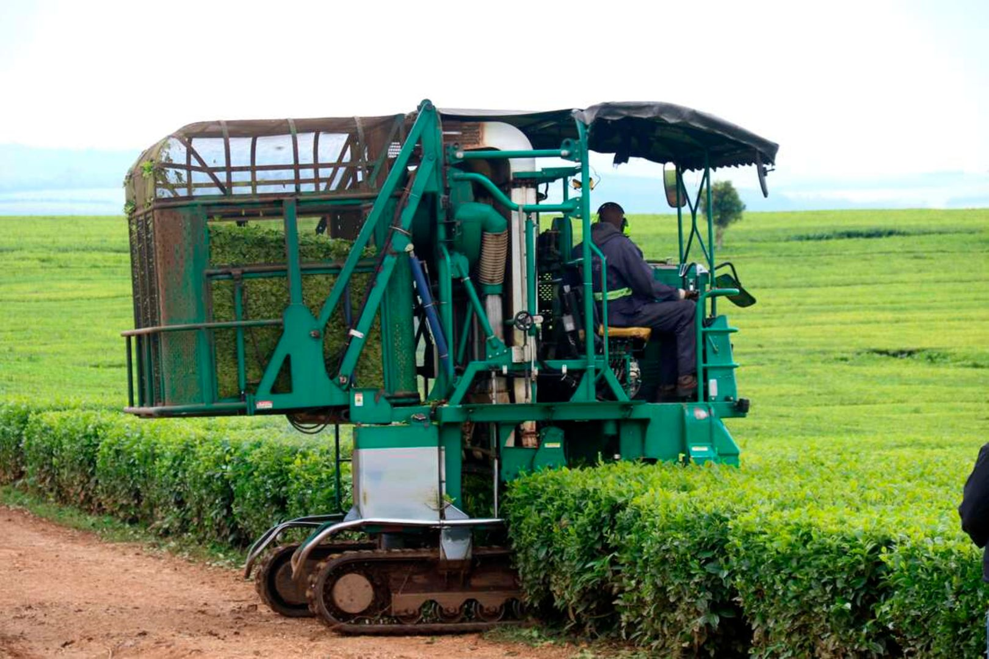
a)i)Identify the type of photograph (1mk)
ii)Identify the activity shown in the photography. (1mk)
iii)Give two counties where the activity shown in the photography above takes place in Kenya . (2mks)
iv)Identify two problems associated with the machine used in the photograph . (2mks)
b)Explain four physical conditions that favour tea farming in Kenya . (8mks)
c.)i)Describe tea processes from cultivation to harvesting . (8mks)
ii)Give three reasons for the increase in the maize prices in Kenya . (3mks)

7.a)i)Name three minerals that occur as alluvial deposits . (3mks)
ii)Describe open cast mining method . (4mks)
iii)State three ways in which mining derelict land can be rehabilitated . (3mks)
b)Explain four significance of gold mining to the economy of South Africa . (8mks)
c)The diagram below shows a sketch map of the Zuider Zee project
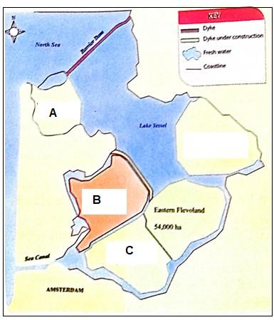
i)Identify the sections marked A,B and C (3mks)
ii)Explain two differences in land reclamation in Netherlands and Kenya. (4mks)

8.a)i)Name four rivers in Kenya that are used to generate Hydroelectric power . (4mks)
ii)Explain four causes of energy crisis in Kenya . (8mks)
b) State five physical factors that favoured the development of the Seven Fork Scheme hydro electric power projects . (5mks)
c) Explain four measures the government of Kenya has taken to conserve energy . (8mks)

9.a)i)Give five reasons for high population in Kenya . (5mks)
ii)Explain four positive effects of low population growth in a country . (8mks)
b) Give four factors that influence the development of linear settlement pattern. (4mks)
c) Explain four measures the county government in Kenya are undertaking to control child mortality . (8mks)

10.a(i) what is environmental hazard ? (2mks)
ii) Name three causes of water pollution . (3mks)
b) i) Explain four effects of floods in the lake region . (8mks)
ii) Name four agricultural nonfood industries in Kenya . (4mks)
c) Explain four factors that led to growth and development of iron and steel industry in the Ruhr region in Germany . (8mks)

