ST. JOHN’S KOMOLORUME SEC. SCHOOL
Term 1 - 2026
CHEMISTRY (233/1)
PAPER 1
FORM FOUR (4)
Time: 2 Hours

Name: …………………………………………………………. Adm No: ……………….
School: ……………………………………………………….. Class: …………………..
Signature: …………………………………………………….. Date: …………………...
Instructions to candidates
- Write your name, stream, and admission number in the spaces provided above.
- Answer ALL the questions in the spaces provided, and working MUST be clearly shown
- This paper consists of 11 printed pages; Candidates should check the question paper to ascertain that all the pages are printed as indicated, and that no question is missing.

FOR EXAMINERS’ USE ONLY
QUESTIONS | MAXIMUM SCORE | CANDIDATE’S SCORE
1 – 28 | 80

- A magnesium ribbon sample was heated in separate volumes of pure oxygen and air.
- In which sample was the mass of the product higher? Explain. (2 Marks)
___________________________________________________________________________
___________________________________________________________________________
- Write the equations for the reactions in the sample with air. (2 Marks)
___________________________________________________________________________
- Give the systematic name of the following compound and draw the structure of the polymer it forms: CH₂CHCl
Name __________________________________________________________________(1 Mark)
Structure (1 Mark)
______________________________________________________________________________
______________________________________________________________________________
______________________________________________________________________________

- State Charles’ Law (1 Mark)
___________________________________________________________________________
___________________________________________________________________________
- A certain mass of carbon (IV) oxide gas occupied 200cm³ as 25ºC and 750mmHg pressure. Calculate the volume occupied by the same mass of gas if pressure is lowered to 300mmHg and the temperature raised to 30ºC. (2 Marks)
___________________________________________________________________________
___________________________________________________________________________
- Chlorine gas was bubbled into as solution of hydrogen sulphide as shown in the diagram below.
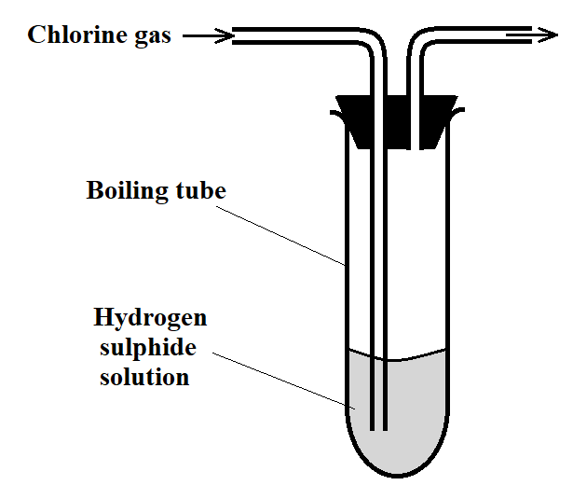
- Explain the observation made in the boiling tube (2 Marks)
___________________________________________________________________________
___________________________________________________________________________
- What precaution should be taken in this experiment? (1 Mark)
___________________________________________________________________________
___________________________________________________________________________
- Distinguish between the bleaching action of chlorine and that of sulphur (IV) oxide. (1 Mark)
___________________________________________________________________________
___________________________________________________________________________
- Concentrated sulphuric (VI) acid was left exposed in air for a few days. It was found that the level of the acid had risen.
- Why did the level of the acid in the container rise? (1 Mark)
___________________________________________________________________________
___________________________________________________________________________
- How is this property useful in the laboratory? (1 Mark)
___________________________________________________________________________
___________________________________________________________________________

- The setup below can be used to dry and collect ammonia gas. Use it to answer the questions that follow.
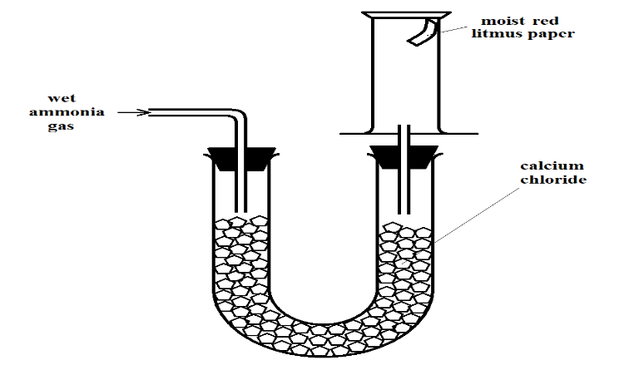
- The wet red litmus paper remained red. Explain. (1 Mark)
___________________________________________________________________________
___________________________________________________________________________
- Name the method used when collecting ammonia gas. (1 Mark)
___________________________________________________________________________
- 400cm³ of gas D diffuses from a porous plug in 50 seconds while 600cm³ of oxygen gas diffuses from the same apparatus in 30 seconds. Calculate the relative molecular mass of gas D. (3 Marks)
______________________________________________________________________________
______________________________________________________________________________
______________________________________________________________________________
- Use the information in the table below on solubility to answer the questions that follow.
Salt | Solubility at
Salt | 70ºC | 35ºC
CuSO₄ | 38 | 28
Pb(NO₃)₂ | 78 | 79

A mixture containing 38g copper (II) sulphate and 78g of lead (II) nitrate in 100g of water at 70ºC is cooled to 35ºC.
- Which of the two salts will crystallize? (1 Mark)
___________________________________________________________________________
- Calculate the mass of crystals formed. (1 Mark)
___________________________________________________________________________
___________________________________________________________________________
- State the salt that will be unsaturated at 35ºC (1 Mark)
___________________________________________________________________________
- How much of the salt in c) above would be required to make a saturated solution at 35ºC? (1 Mark)
___________________________________________________________________________
___________________________________________________________________________
- Given solid sodium carbonate, lead (II) nitrate crystals and water, explain how you can obtain a solid sample of lead (II) carbonate. (3 Marks)
______________________________________________________________________________
______________________________________________________________________________
______________________________________________________________________________
______________________________________________________________________________
______________________________________________________________________________

- A solution of hydrogen chloride gas in water conducts an electrical current, while that of hydrogen chloride in methylbenzene does not conduct. Explain. (2 Marks)
______________________________________________________________________________
______________________________________________________________________________
______________________________________________________________________________
- The scheme below shows some reactions, starting with ethyne. Study it and answer the questions that follow.
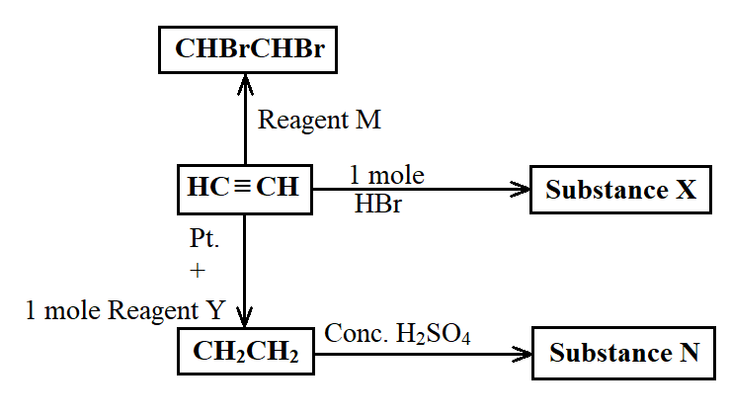
- Name substance
- X ______________________________________________________________ (½ Mark)
- N ______________________________________________________________ (½ Mark)
- M ______________________________________________________________ (½ Mark)
- Ethene undergoes polymerization to form a polymer. Give an equation for the reaction and name the product. (1½ Marks)
___________________________________________________________________________
___________________________________________________________________________
- The electron arrangement of ions X³⁺ and Y²⁻ are 2.8, and 2.8.8 respectively.
- In which groups do X and Y belong? (1 Mark)
X___________________________ Y_____________________________________
- State the formula of the compound that would be formed between X and Y (1 Mark)
___________________________________________________________________________

- The setup below was used to investigate the effect of carbon (II) oxide on zinc oxide.
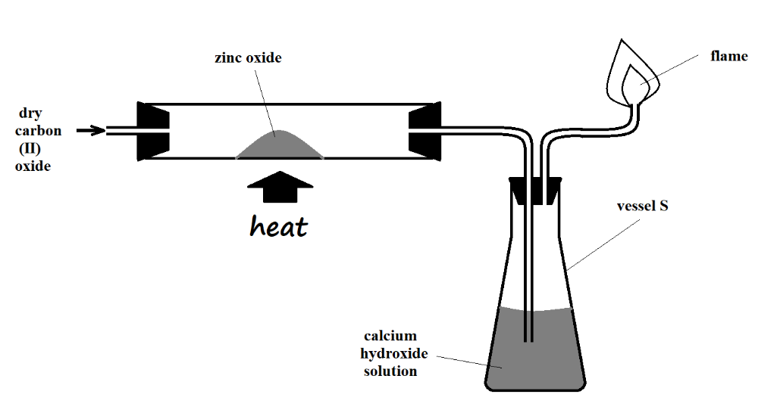

- State the observations made on the setup. (2 Marks)
___________________________________________________________________________
___________________________________________________________________________
- Write equations for the reactions that took place. (2 Marks)
___________________________________________________________________________
___________________________________________________________________________

- The grid below represents part of the periodic table. Study it and answer the questions that follow. The letters do not represent actual symbols of the elements
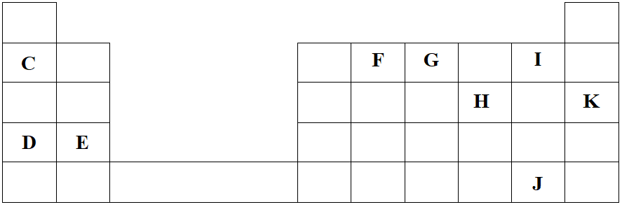
- Identify the most reactive non-metal. Explain (2 Marks)
___________________________________________________________________________
___________________________________________________________________________
___________________________________________________________________________
- What is the name given to the family of elements to which I and J belong? (1 Mark)
___________________________________________________________________________
- Using dots (•) and crosses (×) to represent electrons, show bonding in the compound formed between C and H. (2 Marks)

- How does the atomic radius of F compare with that of I? Explain. (2 Marks)
___________________________________________________________________________
___________________________________________________________________________
___________________________________________________________________________
- Study the table below and answer the questions that follow.
Substance | M | N | O | P | Q | R
Melting Point (ºC) | 801 | 1356 | -101 | 26 | -39 | 113
Boiling Point (ºC) | 1410 | 2850 | -36 | 154 | 457 | 445
Electrical conductivity in solid state | Poor | Poor | Poor | Poor | Good | Poor
Electrical conductivity in molten state | Good | Poor | Poor | Poor | Good | Poor

- Explain why substance M is a good conductor of electricity in the molten state but not in the solid state. (2 Marks)
___________________________________________________________________________
___________________________________________________________________________
___________________________________________________________________________
- What is the most likely structure and bond in substance N? Explain. (2 Marks)
Structure ____________________________ Bond ___________________________
__________________________________________________________________________
__________________________________________________________________________
- Identify, with a reason, a substance that exists as a liquid at room temperature. (2 Marks)
___________________________________________________________________________
___________________________________________________________________________
___________________________________________________________________________

- What name is given to different forms of an element which exist in the same physical state? (1 Mark)
___________________________________________________________________________
- Name two crystalline forms of carbon (1 Mark)
__________________________________ _________________________________
- The figure below is part of a setup used to prepare and collect dry carbon (II) oxide from carbon (IV) oxide.
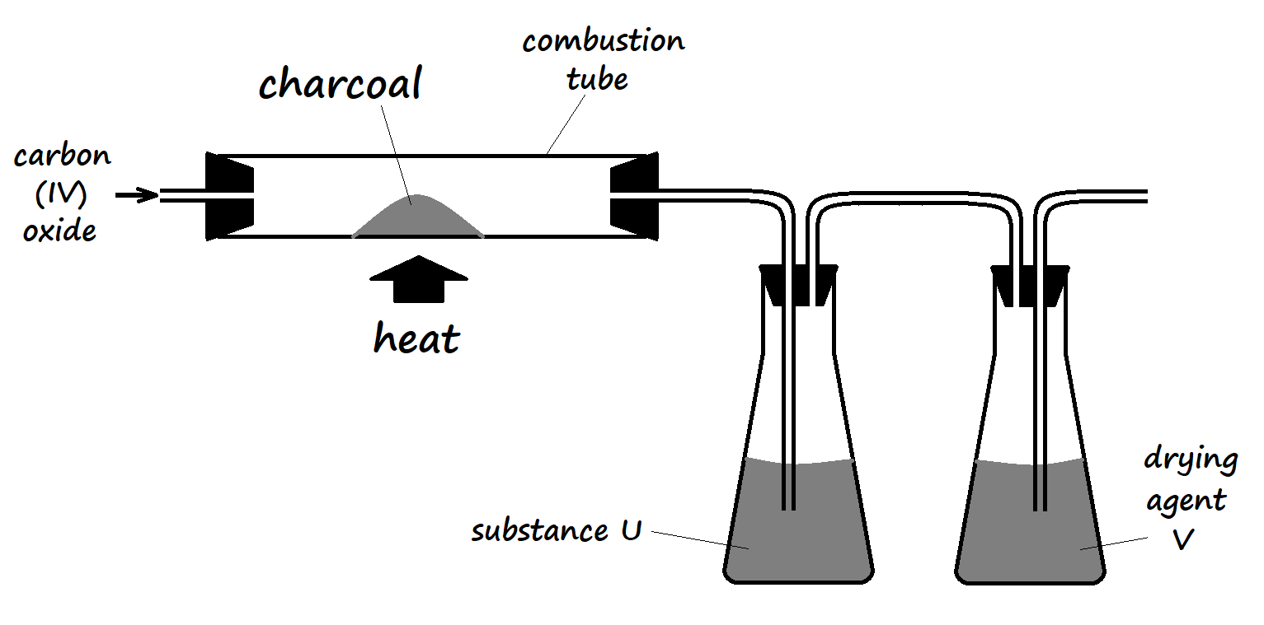
- Complete the diagram to show how dry carbon (II) oxide gas is collected. (1 Mark)
- Identify:
- Substance U and state its use
_____________________________________________________________________
_____________________________________________________________________
- Drying agent Y
_____________________________________________________________________
- Write a chemical equation for the reaction which takes place in the combustion tube (1 Mark)
___________________________________________________________________________
- Carbon (II) oxide is a major environmental pollutant.
- Give one major source of carbon (II) oxide in the atmosphere (1 Mark)
_____________________________________________________________________
- Explain how carbon (II) oxide causes poisoning (1 Mark)
_____________________________________________________________________
_____________________________________________________________________
- State one use of carbon (II) oxide (1 Mark)
___________________________________________________________________________
- Write an equation for the formation of water gas. (1 Mark)
___________________________________________________________________________
- Explain why sodium hydroxide solution is not used in testing for carbon (IV) oxide gas, while calcium hydroxide is preferably used. (2 Marks)
___________________________________________________________________________
___________________________________________________________________________
___________________________________________________________________________

- The diagram below shows part of the Frasch process, used for the extraction of sulphur. Use it to answer the questions that follow.
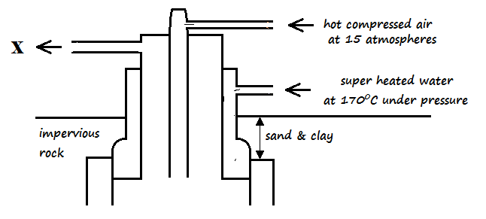
- Identify X ________________________________________________________(1 Mark)
- Why is it necessary to use superheated water and hot compressed air in this process? (2 Marks)
___________________________________________________________________________
___________________________________________________________________________
___________________________________________________________________________
- State two physical properties of sulphur that makes it possible for it to be extracted by this method. (2 Marks)
___________________________________________________________________________
___________________________________________________________________________

- The diagram below shows part of the process in the manufacture of sulphuric (VI) acid. Study it and use it to answer the questions that follow.
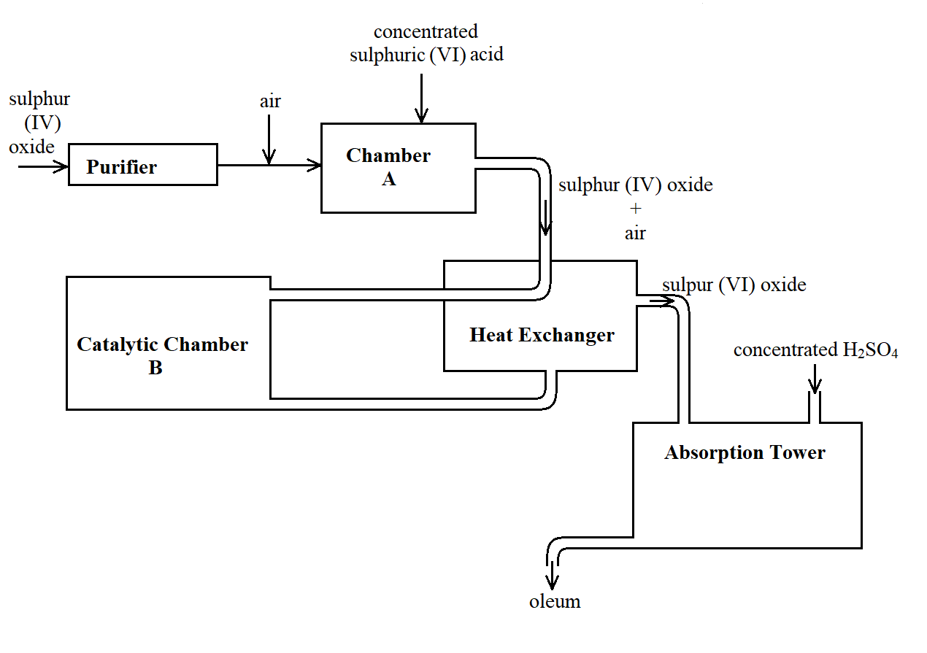
- Give two reasons why air is referred to as a mixture (2 Marks)
___________________________________________________________________________
___________________________________________________________________________
- What is the role of concentrated sulphuric (VI) acid in Chamber A? (1 Mark)
___________________________________________________________________________
___________________________________________________________________________
- Name two catalysts that can be used in the Catalytic Chamber B. (2 Marks)
___________________________________________________________________________
___________________________________________________________________________
- State two roles of the heat exchanger (2 Marks)
___________________________________________________________________________
___________________________________________________________________________
- Describe the test for sulphite anion, SO₃²⁻ (2 Marks)
___________________________________________________________________________
___________________________________________________________________________
___________________________________________________________________________
- Explain the observation made when a few drops of concentrated sulphuric (VI) acid are added to crystals of hydrated copper (II) sulphate. Explain your answer. (2 Marks)
___________________________________________________________________________
___________________________________________________________________________
___________________________________________________________________________
- (a) The table below shows the ions of elements W,X,Y Z and their electron arrangement. The letters do not represent the actual symbols of the elements.

Ion | Electronic Configuration
W⁻ | 2,8,8
X²⁺ | 2,8,8
Y³⁺ | 2,8
Z²⁻ | 2,8

- Which two elements belong to the same period? Give a reason.
(2mks)
___________________________________________________________________________
___________________________________________________________________________

___________________________________________________________________________
- In which group of the periodic table does Y³⁺ belong? (1mk)
___________________________________________________________________________
- Write the formula of the compound formed between W and X (1mk)
___________________________________________________________________________

- What type of bond is formed between W and X, Explain? (3mks)
___________________________________________________________________________
___________________________________________________________________________
__________________________________________________________________________
___________________________________________________________________________

- (i) What is a co-ordinate bond. (1mk)
__________________________________________________________________________
___________________________________________________________________________

(ii) Draw a dot (•) cross (x) diagram to show bonding in the hydroxonium, H₃O⁺ ion. (2mks)

- A hydrocarbon contains 88.2% carbon. Its molecular mass is 68g.
  - (i) Determine its empirical and molecular formula. (2mks)

  - Draw two positional isomers of the hydrocarbon. (1mk)

