NAME………………………………………………….INDEX NO…………………………
CANDIDATE’S SIGN………………………………..DATE……………………………….
SCHOOL……………………………………………………………………………………….

231/2
BIOLOGY
PAPER 2
THEORY
AUGUST 2023
TIME: 2 HOURS

KIRINYAGA CENTRAL SUB-COUNTY EFFECTIVE ‘40’ JOINT EXAMINATION 2023
Form Four
Kenya Certificate of Secondary Education (K.C.S.E)

INSTRUCTIONS TO CANDIDATES

- Write your Name and Index Number in the spaces provided.
- Sign and write the Date of examination.
- This paper consists of two sections, A and B.
- Answer ALL questions in section A in the spaces provided.
- In section B, answer question 6 (compulsory) and then answer question 7 or 8 in the spaces provided after question 8.
- Candidates may be penalized for false information and even wrong spellings of technical terms.
- This paper consists of 8 printed pages.
- Candidates should check to ensure that all pages are printed as indicated and no questions are missing.

FOR EXAMINER’S USE ONLY

SECTION | QUESTIONS | MAXIMUM SCORE | CANDIDATE’S SCORE
A | 1 | 8
A | 2 | 8
A | 3 | 8
A | 4 | 8
A | 5 | 8
B | 6 | 20
B | 7 | 20
B | 8 | 20
TOTAL SCORE |  | 80

SECTION A (40 MARKS)

- The diagram below is a set up to investigate a certain physiological process. Glucose solution was boiled and cooled before adding yeast.
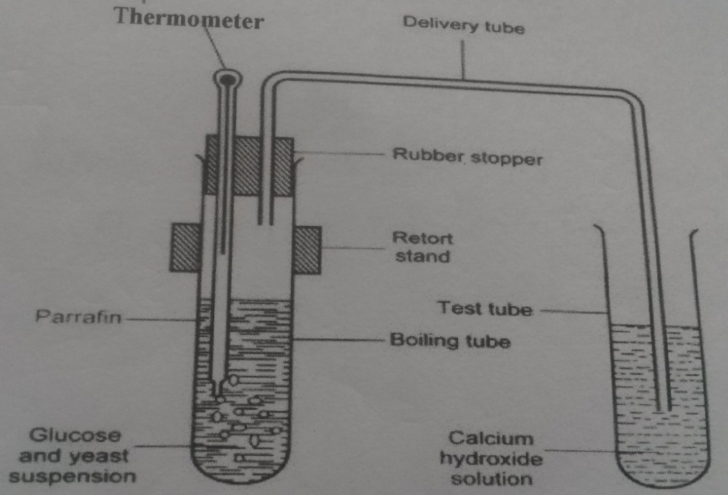

- Name the physiological process that was being investigated. (1mk)
………………………………………………………………………………………………………….
- Explain why:
- Glucose solution was boiled. (1mk)
…………………………………………………………………………………………………………………………………………………………………………………………………...
- Glucose solution was cooled before added yeast. (1mk)
……………………………………………………………………………………………………………………………………………………………………………………………………
- What is the role of paraffin? (1mk)
…………………………………………………………………………………………………………
- State the observation that would be made in the test tube containing calcium hydroxide solution if the set up was left undisturbed for 30 minutes. (1mk)
…………………………………………………………………………………………………………………………………………………………………………………………………………………….
- Account for the observation made in (d) above. (2mks)
…………………………………………………………………………………………………………………………………………………………………………………………………………………….
- Write word equation for the physiological process under investigation. (1mk)
……………………………………………………………………………………………………………………………………………………………………………………………………………………..
- (a) In evolution, what do you understand by:-
- Convergent Evolution? (1mk)
………………………………………………………………………………………………….
- Organic Evolution?
………………………………………………………………………………………………
(b) State three limitations of fossils as evidences of organic evolution. (3mks)
……………………………………………………………………………………………………………………………………………………………………………………………………………………………………………………………………………………………………………………………….
(c) Name three types of skeletons in animals. (3mks)
……………………………………………………………………………………………………………………………………………………………………………………………………………………………………………………………………………………………………………………………….
- Students set up an experiment as illustrated below. The set up was left for 30 minutes.
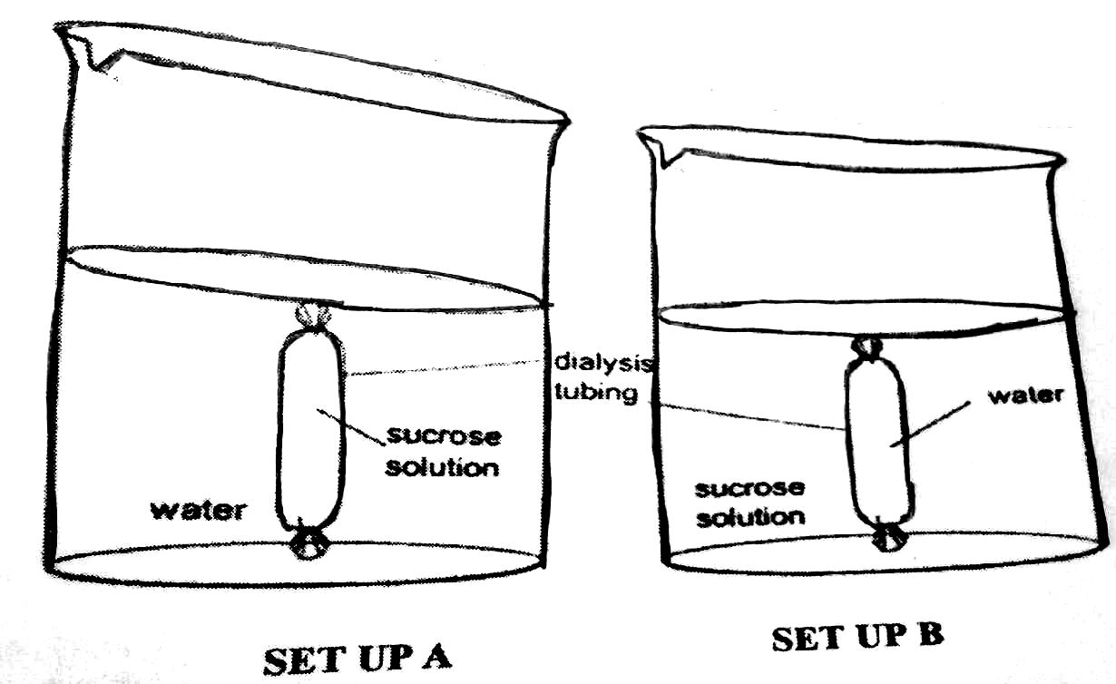
- Name the physiological process that was being investigated by students. (1mk)
………………………………………………………………………………………………………….
- State the observations made on the set up A and B. (2mks)
- Set up A
…………………………………………………………………………………………………..
- Set up B
…………………………………………………………………………………………………..
- Explain the observations made in the set up A after 30 minutes. (2mks)
………………………………………………………………………………………………………………………………………………………………………………………………………………………………………………………………………………………………………………………………
- State the importance of the physiological process investigated in animals. (1mk)
……………………………………………………………………………………………………………………………………………………………………………………………………………………..
- Explain what happens to a red blood cell when placed in distilled water. (2mks)
…………………………………………………………………………………………………………
…………………………………………………………………………………………………………………………………………………………………………………………………………………….
- (a) The diagram below shows represents a stage during cell division.
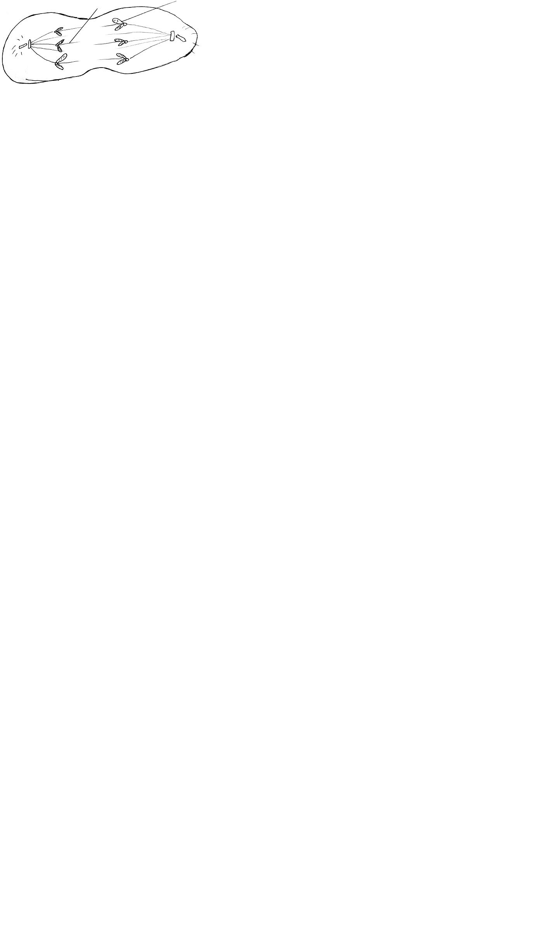
K Daughter Chromose

- Identify the stage during cell division. (1mk)
…………………………………………………………………………………………………
- Give two reasons for your answer in (i) above. (2mks)
……………………………………………………………………………………………………………………………………………………………………………………………………
- Give the name of structures labeled K and state their role during cell division.
Name:…………………………………………………….. (1mk)
Function: …………………………………………………. (1mk)
(b) (i) Give two advantages of cross pollination in flowering plants. (2mks)
…………………………………………………………………………………………………
………………………………………………………………………………………………….
(ii) Name one mechanism that ensures that cross pollination takes place in flowering plants.
(1mk)
…………………………………………………………………………………………………

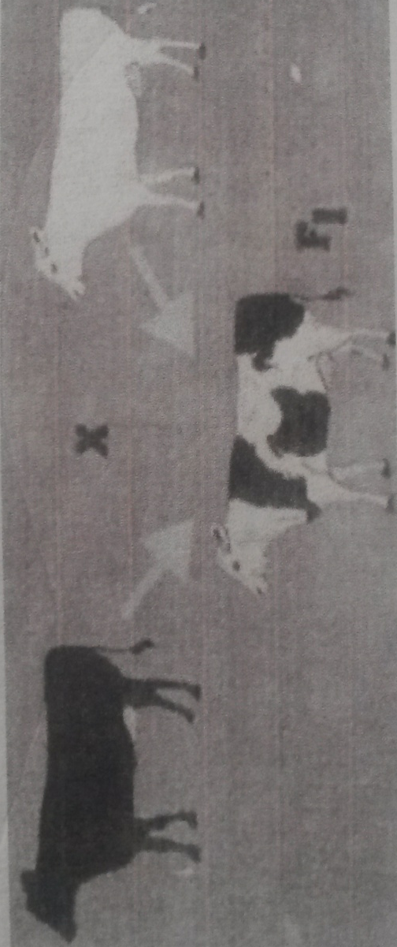
- The photograph below shows a cross between cattle in a certain village. Study it and answer the questions that follow:-

- Using evidence in the photograph only, comment on the genes controlling the white and black colour in the cattle involved in the cross. (1mk)
……………………………………………………………………………………………………………………………………………………………………………………………………………………
- Using letter B for black colour and W for white colour, show the genotypic ratio of the F2 generation in the cross above. (5mks)

- State human trait showing the same characteristic. (1mk)
…………………………………………………………………………………………………………
- Name any one sex-linked trait in human. (1mk)
………………………………………………………………………………………………………

SECTION B (40 MARKS)
Answer question 6 (compulsory) in the spaces provided and either question 7 or 8 in the spaces provided after question 8.

- An experiment was carried out to investigate the effects of hormones on growth of lateral buds of three pea plants. The shoot were treated as follows:-
Shoot A: Apical bud was removed.
Shoot B: Apical bud was removed and Gibberellic acid placed on the shoot.
Shoot C: Apical bud was left intact.
The lengths of the branches developing from the lateral buds were determined at regular intervals. The results obtained are shown in the table below.
Time (days) | Length of Branches (mm)
Time (days) | Shoot A | Shoot B | Shoot C
0 | 3 | 3 | 3
2 | 10 | 12 | 3
4 | 28 | 48 | 8
6 | 50 | 90 | 14
8 | 80 | 120 | 20
10 | 118 | 152 | 26
- Using same axis, draw graphs to show the lengthof branches against time. (8mks)

(ii) What was the length of branches on the 7th day? (1mk)
……………………………………………………………………………………………………….
- (i) What would be the expected length of the branch developing from shoot B on the 11th day?
(1mk)
………………………………………………………………………………………………………
(ii) Account for the results obtained in the experiment. (2mks)
……………………………………………………………………………………………………
- Why was shoot C included in the experiment? (1mk)
……………………………………………………………………………………………………………………………………………………………………………………………………………………
- State four physiological processes that are brought about by application of Gibberellic acid on plants. (4mks)
………………………………………………………………………………………………………………………………………………………………………………………………………………………………………………………………………………………………………………………………………………………………………………………………………………………………………….
- State the role of the following in seed germination:-
- Water (2mks)
……………………………………………………………………………………………………
- Enzymes (1mk)
……………………………………………………………………………………………………
- (a) Explain the photosynthetic theory of opening and closing of stomata. (6mks)
(b) Describe how terrestrial plants are adapted to deal with the problem of water loss through
transpiration. (7mks)
(c) Describe the process of blood clotting in man. (7mks)
- Describe how the mammalian eye is adapted to its functions. (20mks)
.........................................................................................................................................................................................................................................................................................................................................................................................................................................................................................................................................
.........................................................................................................................................................................................................................................................................................................................................................................................................................................................................................................................................
.........................................................................................................................................................................................................................................................................................................................................................................................................................................................................................................................................
.........................................................................................................................................................................................................................................................................................................................................................................................................................................................................................................................................
.........................................................................................................................................................................................................................................................................................................................................................................................................................................................................................................................................
.........................................................................................................................................................................................................................................................................................................................................................................................................................................................................................................................................
.........................................................................................................................................................................................................................................................................................................................................................................................................................................................................................................................................
.........................................................................................................................................................................................................................................................................................................................................................................................................................................................................................................................................
.........................................................................................................................................................................................................................................................................................................................................................................................................................................................................................................................................
............................................................................................................................................................................................................................................................................................................................................................................................................................................................................................................................................................................................................................................................................................................................................................................................................................................................................................................................................................................................................................................................................................................................................................................................................................................................................................................................................................................................................................................................................................................................................................................................................................................................................................................................................................................................................
....................................................................................................................................................................................................................................................................................................................................................................................................................................................................................................................................................................................................................................................................................................................................................................................................................................................................................................................................................................................................................................................................................
........................................................................................................................................................................................................................................................................................................................................................................................................................................................................................................................................................................................................................................................................................................................
............................................................................................................................................................................................................................................................................................................................................................

