

Name: __________________________________ School: __________________

Class: _______Admission Number: ______/ Index Number: ______________

Date: ___________

312/2
GEOGRAPHY PAPER 2
MAY 2026

TIME: 2 HRS 45 MINS

MIDGEA GEOGRAPHY EXAMINATION
FORM 4 TERM 2, 2026 SERIES

INSTRUCTIONS TO CANDIDATES
- This paper contains two sections; A and B.
- Answer all questions in section A.
- Answer question 6 and any other two questions from section B.
- All answers must be written in the answer sheets provided.

For Examiner’s use only
Section | Question | Maximum Score | Candidate’s Score
A | 1 - 5 | 25
B | 6 | 25
B |  | 25
B |  | 25
 | Total Score | 100

SECTION A (25 MARKS)
Answer all questions in this Section

1.a) Give three differences between natural and planted forests (3mks)
b) Name two indigenous hardwood trees in Kenya (2mks)
2.(a) Apart from water, give two other renewable sources of energy which are utilized in Kenya. (2mks)
(b) State three advantages of using hydro-electric power over other forms of energy. (3mks)

3.(a) Name two Exotic breeds of cattle reared in Kenya and Argentina. (2mks)

(b) State three steps taken by the government to improve beef farming in Kenya. (3mks)

4 a)What is the difference between an industry and industrialization. (2mks)
(b)Give three reasons why the government of Kenya encourages industrialization in the country. (3mks)
5 (a) Give three reasons why it is necessary to study geography through fieldwork (3mks)
(b) State two disadvantages of direct observation as a method of data collection (2mks)
SECTION B (75 MARKS)
Answer question 6 and any other two questions from this Section
6. Study the photograph below and use it to answer the questions that follow.

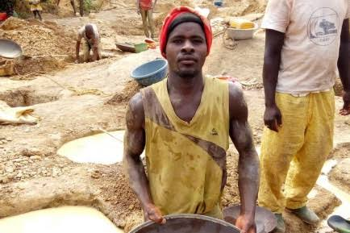

(a) i.) Name the type of photograph shown above. (1mk)
ii) Which type of mining is this (1mk)
iii. Draw a rectangle measuring 12cm by 10cm to represent the area on the
photograph. On the rectangle, mark and label three main features (4mks)
(b)(i) Explain Two physical factors that affect exploitation of minerals in Africa. (4mks)
(ii) Describe flush mining method (3mks)
(iii) Explain two ways in which mining leads to loss of biodiversity . (4mks)
(c )Explain four factors why Kenya has not fully exploited her minerals deposits (8mks)
7.The table below shows the area under the horticultural crops in Kenya between 2000 and 2002. Use it to answer the questions below:
Crop | 2000 | 2001 | 2002
Cabbages | 320 | 340 | 380
Tomatoes | 360 | 360 | 330
Onions | 340 | 320 | 360
Oranges | 380 | 380 | 400

- (i)Name the crop that has the highest production within the period (1mk)
(ii)Explain THREE reasons why horticultural farming is increasingly becoming important to Kenyan farmers. (6mks)
- Using 1cm to represent 10000 tonnes, draw a compound bar graph to present the data above. (6mks)
- Give FOUR features of horticultural farming. (4mks)
- Explain Similarities between horticulture in Kenya and Netherlands . (8mks)

8. a)(i)State three physical condition that may discourage the setting up of Game Reserves and National Parks. (3mks )
(ii)Name two game reserves in Kenya (2mks )
b)(i)Differentiate between Domestic tourism and international tourism. (2mks)
(ii) Explain four factors that hinder the development of domestic tourism in Kenya. (8mks)
(iii) State four problems Experienced by the Kenya government in its efforts to conserve wildlife. (4mks)
c) Explain three reasons why Switzerland receive more tourists than Kenya. (6mks)
9. (a) i) Define the term fisheries (2mks)
ii) State three factors that favour the growth of planktons (3mks)
b) The map below shows the North-West Atlantic fishing grounds. Study it and answer the questions that follow

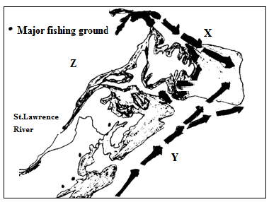

- Name the ocean currents marked X and Y (2mks)
- Explain how ocean currents X and Y favour fishing in the North-West Atlantic (4mks)
- Name the county marked Z (1mk)
- Name three examples of fish found in the North-West Atlantic fishing grounds (3mks)
c) Explain three reasons that make East Africa not to be a major producer of fish and fish products in the world (6mks)
d) Explain four measures that Kenyan government has undertaken to conserve fisheries (4mks)

10.(a) (i) Differentiate between land reclamation and land rehabilitation . (2mks)
(ii) Name two methods of rehabilitating land in Kenya . (2mks)
(iii) Explain three physical factors that influence the establishment of Pekerra irrigation scheme. (6mks)
(b) Explain three problems facing irrigation farming in Kenya. (6mks)
(c ) (i)Describe the stages that were involved in the reclamation of polders in Netherlands
(5mks)
(ii)List four benefits of the Delta plan project in Netherlands. (4mks)

