

Name: ________________________________ School: _____________

Class: _________Admission Number: ___________Date:___________

FORM 3 TERM 2, 2026 GEOGRAPHY CONTEST PAPER
MAY 2026

TIME: 2 HRS

INSTRUCTIONS TO THE CANDIDATES
- This paper contains five sections; A, B, C, D and E.
- Answer all questions in this paper in the answer sheet provided.
- Answer the questions in English.

FOR EXAMINER’S USE ONLY
SECTION | AREAS COVERED | MAXIMUM SCORE | CANDIDATE’S SCORE
A | Physical Geography - Structured | 20
B | Map work | 20
C | Statistical methods | 20
D | Photograph work | 20
E | Climate, vegetation and field work | 20

TOTAL SCORE

SECTION A: PHYSICAL GEOGRAPHY – STRUCTURED

1. What is geography . (2 mks)

2.Describe the solar system . (2 mks)
3.The diagram below shows some intrusive volcanic features
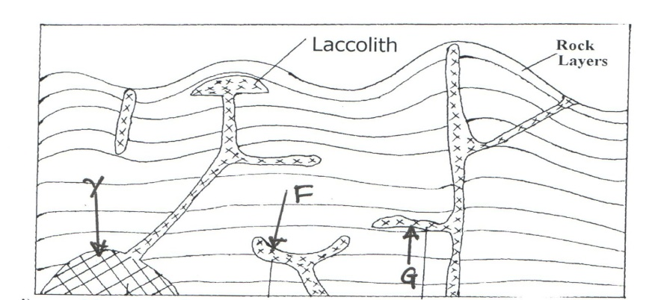

(a). Name the features marked F,G and Y. (3 mks)
(b).Describe how laccolith is formed . (4 mks)
4. (a) Differentiate between weathering and mass wasting. (2mks)
(b) State two physical conditions that may influence landslides (2mks)

5(a)Give three processes in the hydrological cycle. (3 mks)
(b) Name two sources of rivers (2 mks)

SECTION B: MAP WORK.

6. Study the map of KIPKABUS 1:50,000 (sheet 104/1) provided and answer the questions that follow.

a(i) Give the latitude and longitude of the South west corner of the map extract.
(1 mk)
(ii) Name the planted vegetation in the area covered by the map (1 mk)
iii) Identify two physical features found at grid square 9228 (2mks)
b)Describe relief of the area covered by the map (5mks)
c)Citing evidence from the map ,identify three social services offered in the area covered by the map (6 mks)
(d)Draw a rectangle measuring 16 cm by 20cm to represent the area bound by Easting 80 and 84 and Northing 36 and 41 . (2 mks)
On it mark and name
- A dam 1mk
- Bamboo 1mk
- Dry weather road 1mk
SECTION C: STATISTICAL METHODS.

7. Study the data in the following table and answer questions (a) and (b)
. Kenyas leading Exports by value (Ksh Million)
MINERAL | 2019 | 2020 | 2021
SODA ASH | 14,030 | 12702 | 7,560
SALT | 34,070 | 36150 | 38,485
GOLD | 756 | 500 | 1101

(a)Draw Cummulative bars to represent the total earnings of the years 2019 to 2021. (Use a scale of 1 cm rep 10,000 Kshs. Million ) (12 mks)
(b)i)State two advantages of using this method of data presentation (2mks)
( ii) Give two other methods of data presentation that can be used to present this data (2mks)
(c )Identify four uses of soda ash . (4mks)

SECTION D: PHOTOGRAPH WORK.
8. Study the photograph shown below and answer the questions that follow..

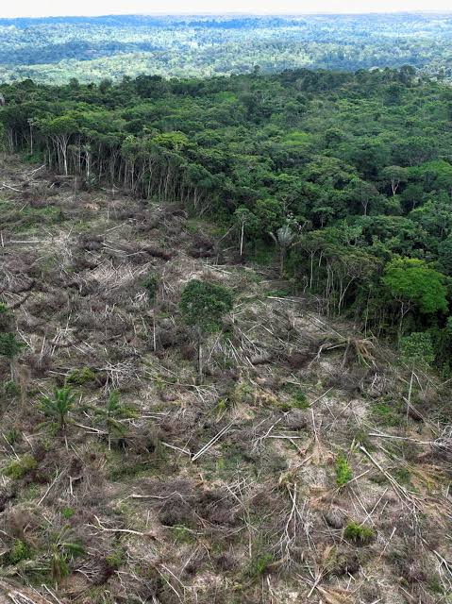
(a) (i) Identify the type of photograph shown above. (1 mk)
(ii) Describe the characteristics of the forest shown on the photograph.
(3 mks)

(iii) Draw a rectangle measuring 15 cm by 10 cm. On it, sketch an d label five main features shown on the photograph. (5 mks)

(b) (i)Name two indigenous softwood tree species in Kenya. (2 mks)

(ii) Explain three problems facing forestry in Kenya. (6 mks)
(iii) State three factors favouring the development of softwood forests in Canada. (3 mks)
SECTION E: CLIMATE, VEGETATION AND FIELD WORK.

9. (a) (i) Differentiate between weather and climate. (1 mk)
(ii) Explain how the following factors influence climate.
- Warm ocean currents (2 mks)
- Latitude (2 mks)
(b) The graph below represents the climate for a station in Kenya.
Describe the characteristics of climate represented by the graph. (5 mks)

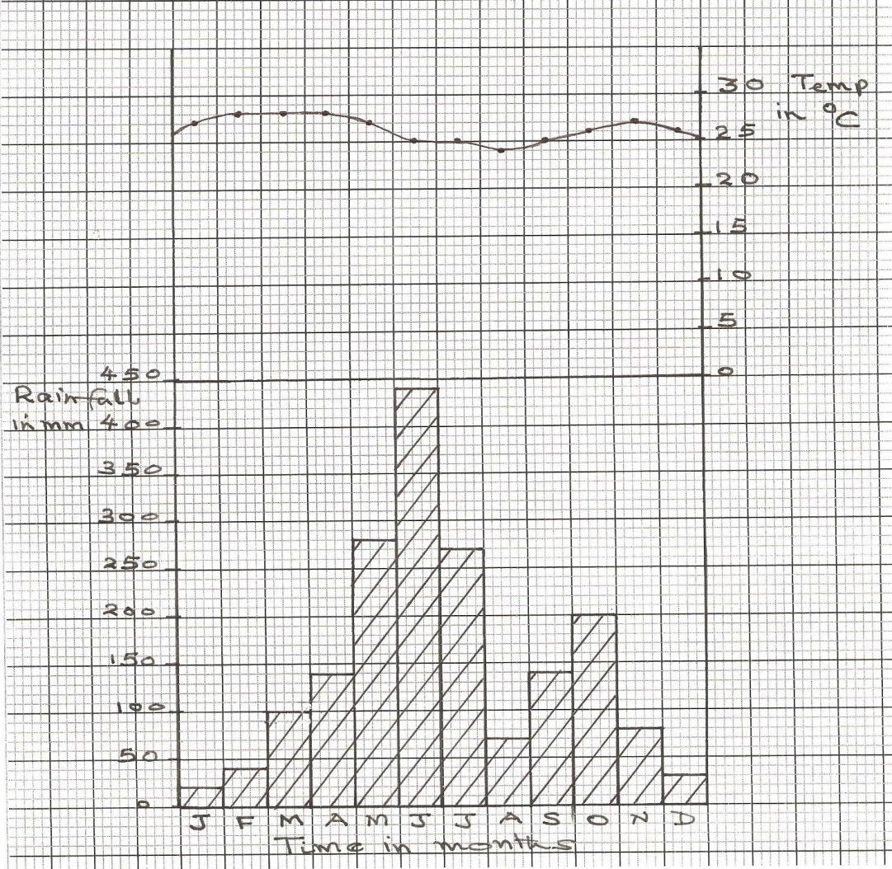
(c) Explain how tropical savanna vegetation is adapted to the climatic conditions of their locations (6mks)
(d) Form Three Geography students in your school are planning to carry out a field study on forest vegetation around the school.
(i) Give two objectives for their study. (2mks)
(ii) Give two follow-up activities they would be involved in. (2mks)

