

THE ELITE JET




312/1 GEOGRAPHY Paper 1
PRE-MOCK
March 2026 – Time: 2¾ hours

Admission No……………………………………………………… Index. No.………................………………………..

School……………….…………………………………………….……Date………..….…Signature………………….…….

Instructions to candidates
- Write your name, index number and school in the spaces provided above.
- Sign and write the date of examination in the spaces provided above.
- This paper consists of two sections, A and B.
- Answer all the questions in section A.
- In section B answer question 6 and any other two questions.
- Answers must be written in the spaces provided at the end of question 10.
- This paper consists of 16 printed pages.
- Candidates should check the question paper to ascertain that all the pages are printed as indicated and that no questions are missing.
- Candidates should answer the questions in English.
FOR EXAMINER’S USE ONLY
Section | Question | Maximum Score | Candidate’s Score
A | 1 – 5 | 25
B | 6 | 25
B |  | 25
B |  | 25
TOTAL SCORE |  | 100

SECTION A (25 marks)
Answer ALL questions in this section
- (a) Define the term physical environment. (2 marks)
(b) What is the relationship between Geography and Chemistry? (2 marks)
- (a) What is an eclipse? (2 marks)
(b) Give three conditions necessary for the occurrence of a lunar eclipse. (3 marks)
- The diagram below shows a waterfall. Use it to answer the question that follow.
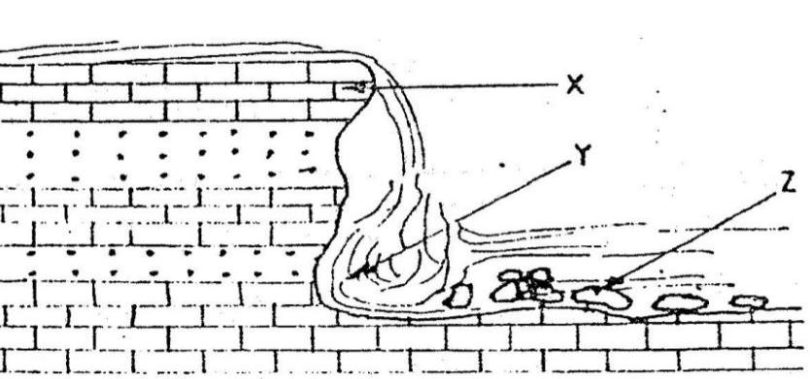
(a) Name the features marked X, Y and Z (3 marks)
(b) List two processes of river transportation. (2 marks)
- Describe the formation of an overthrust fold. (5 marks)
(b) State three factors that influence the amount of surface run-off. (3 marks)

- (a) Name three major earthquake zones of the world (3 marks)
(b) State two effects of earthquake on the earth’s crust (2 marks)

SECTION B : ( 75 marks)
Answer question 6 and any other two questions from this section
- Study the map of Tambach (1:50,000) provided and answer the following questions.

- (i) Give the longitudinal extent of the area covered by the map? (2 marks)
(ii) Name the three human-made features in the grid square 9663. (3 marks)
(iii) Identify two methods used to show relief on the map. (2 marks)
- Calculate the area bounded by Kaptagat forest. Give your answer in square kilometers.
(2 marks)
- Describe the relief of the area covered by the map. (5 marks)
- i) Name three forms of land transport found in the area covered by the map. (3 marks)
ii) Citing evidence from the map, state two social services offered in Tambach municipality. (8 marks)

- (a)(i) Define a rock cycle. (2 marks)
(ii) Describe the following characteristics of minerals
- Tenacity (2 marks)
- Hardness (2 marks)
(b) Describe how the following types of rocks are formed.
- Igneous rocks. (5 marks)
(ii) Thermodynamic metamorphism (5 marks)
(c) Identify the type of rocks which dominate the following region of Kenya: (3 marks)
- Coast
- Central
- Nyanza
(d) Explain the significance of rocks to the economy of Kenya under the following;
- Tourism (4 marks)
- Agriculture. (2 marks)

- (a) Differentiate between magma and lava. (2 marks)
(b) The diagram below shows some features of vulcanicity
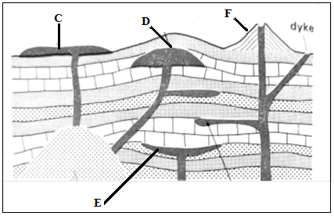
(i) Identify the features marked C, D and E (3 marks)
(ii) Give three characteristics of a Composite Volcano (3 marks)
(c) Describe how a lava plateau is formed (7 marks)
(d) Explain the positive effects of vulcanicity to man (10 marks)

- (a)(i) Define an Ocean (2 marks)
(ii) Explain the three causes of variation in the amount of salt in ocean water (6 marks)
(b)(i) Identify three processes involved in wave erosion (3 marks)
(ii) With the aid of well labelled diagrams, describe the processes through which a wave cut
platform is formed (8 marks)
(c) You intend to carry out a field study on types of features resulting from wave deposition along
the coast.
(i) Identify three methods you would use to record data (3 marks)
(ii) Give three wave depositional features you are likely to observe during the field study
(3 marks)

- (a) Differentiate between eluviation and illuviation. (2 marks)
(b) Explain how the parent rock influences soil formation. (6 marks)
(c) Describe the following processes of soil formation.
- Lateraliztion (6 marks)
- Salinization. (5 marks)
(d) State six characteristics of zonal soils. (6 marks)
……………………………………………………………………………………………………………………………………………………………………………………………………………………………………………………………………………………………………………………………………………………………………………………………………………………………………………………………………………………………………………………………………………………………………………………………………………………………………………………………………………………………………………………………………………………………………………………………………………………………………………………………………………………………………………………………………………………………………………………………………………………………………………………………………………………………………………………………………………………………………………………………………………………………………………………………………………………………………………………………………………………………………………………………………………………………………………………………………………………………………………………………………………………………………………………………………………………………………………………………………………………………………………………………………………………………………………………………………………………………………………………………………………………………………………………………………………………………………………………………………………………………………………………………………………………………………………………………………………………………………………………………………………………………………………………………………………………………………………………………………………………………………………………………………………………………………………………………………………………………………………………………………………………………………………………………………………………………………………………………………………………………………………………………………………………………………………………………………………………………………………………………………………………………………………
………………………………………………………………………………………………………………………………………………………………………………………………………………………………………………………………………………………………………………………………………………………………………………………………………………………………………………………………………………………………………………………………………………………………………………………………………………………………………………………………………………………………………………………………………………………………………………………………………………………………………………………………………………………………………………………………………………………………………………………………………………………………………………………………………………………………………………………………………………………………………………………………………………………………………………………………………………………………………………………………………………………………………………………………………………………………………………………………………………………………………………………………………………………………………………………………………………………………………………………………………………………………………………………………………………………………………………………………………………………………………………………………………………………………………………………………………………………………………………………………………………………………………………………………………………………………………………………………………………………………………………………………………………………………………………………………………………………………………………………………………………………………………………………………………………………………………………………………………………………………………………………………………………………………………………………………………………………………………………………………………………………………………………………………………………………………………………………………………………………………………………………………………………………………………………………………………………………………………………………………………………………………………………………………………………………………………………………………………………………………………………………………………………………………………………………………………………………………………………………………………………………………………………………………………………………………………………………………………………………………………………………………………………………………………………………………………………………………………………………………………………………………………………………………………………………………………………………………………………………………………………………………………………………………………………………………………………………………………………………………………………………………………………………………………………………………………………………………………………………………………………………………………………………………………………………………………………………………………………………………………………………………………………………………………………………………………………………………………………………………………………………………………………………………………………………………………………………………………………………………………………………………………………………………………………………………………………………………………………………………………………………………………………………………………………………………………………………………………………………………………………………………………………………………………………………………………………………………………………………………………………………………………………………………………………………………………………………………………………………………………………………………………………………………………………………………………………………………………………………………………………………………………………………………………………………………………………………………………………………………………………………………………………………………………………………………………………………………………………………………………………………………………………………………………………………………………………………………………………………………………………………………………………………………………………………………………………………………………………………………………………………………………………………………………………………………………………………………………………………………………………………………………………………………………………………………………………………………………………………………………………………………………………………………………………………………………………………………………………………………………………………………………………………………………………………………………………………………………………………………………………………………………………………………………………………………………………………………………………………………………………………………………………………………………………………………………………………………………………………………………………………………………………………………………………………………………………………………………………………………………………………………………………………………………………………………………………………………………………………………………………………………………………………………………………………………………………………………………………………………………………………………………………………………………………………………………………………………………………………………………………………………………………………………………………………………………………………………………………………………………………………………………………………………………………………………………………………………………………………………………………………………………………………………………………………………………………………………………………………………………………………………………………………………………………………………………………………………………………………………………………………………………………………………………………………………………………………………………………………………………………………………………………………………………………………………………………………………………………………………………………………………………………………………………………………………………………………………………………………………………………………………………………………………………………………………………………………………………………………………………………………………………………………………………………………………………………………………………………………………………………………………………………………………………………………………………………………………………………………………………………………………………………………………………………………………………………………………………………………………………………………………………………………………………………………………………………………………………………………………………………………………………………………………………………………………………………………………………………………………………………………………………………………………………………………………………………………………………………………………………………………………………………………………………………………………………………………………………………………………………………………………………………………………………………………………………………………………………………………………………………………………………………………………………………………………………………………………………………………………………………………………………………………………………………………………………………………………………………………………………………………………………………………………………………………………………………………………………………………………………………………………………………………………………………………………………………………………………………………………………………………………………………………………………………………………………………………………………………………………………………………………………………………………………………………………………………………………………………………………………………………………………………………………………………………………………………………………………………………………………………………………………………………………………………………………………………………………………………………………………………………………………………………………………………………………………………………………………………………………………………………………………………………………………………………………………………………………………………………………………………………………………………………………………………………………………………………………………………………………………………………………………………………………………………………………………………………………………………………………………………………………………………………………………………………………………………………………………………………………………………………………………………………………………………………………………………………………………………………………………………………………………………………………………………………………………………………………………………………………………………………………………………………………………………………………………………………………………………………………………………………………………………………………………………………………………………………………………………………………………………………………………………………………………………………………………………………………………………………………………………………………………………………………………………………………………………………………………………………………………………………………………………………………………………………………………………………………………………………………………………………………………………………………………………………………………………………………………………………………………………………………………………………………………………………………………………………………………………………………………………………………………………………………………………………………………………………………………………………………………………………………………………………………………………………………………………………………………………………………………………………………………………………………………………………………………………………………………………………………………………………………………………………………………………………………………………………………………………………………………………………………………………………………………………………………………………………………………………………………………………………………………………………………………………………………………………………………………………………………………………………………………………………………………………………………………………………………………………………………………………………………………………………………………………………………………………………………………………………………………………………………………………………………………………………………………………………………………………………………………………………………………………………………………………………………………………………………………………………………………………………………………………………………………………………………………………………………………………………………………………………………………………………………………………………………………………………………………………………………………………………………………………………………………………………………………………………………………………………………………………………………………………………………………………………………………………………………
………………………………………………………………………………………………………………………………………………………………………………………………………………………………………………………………………………………………………………………

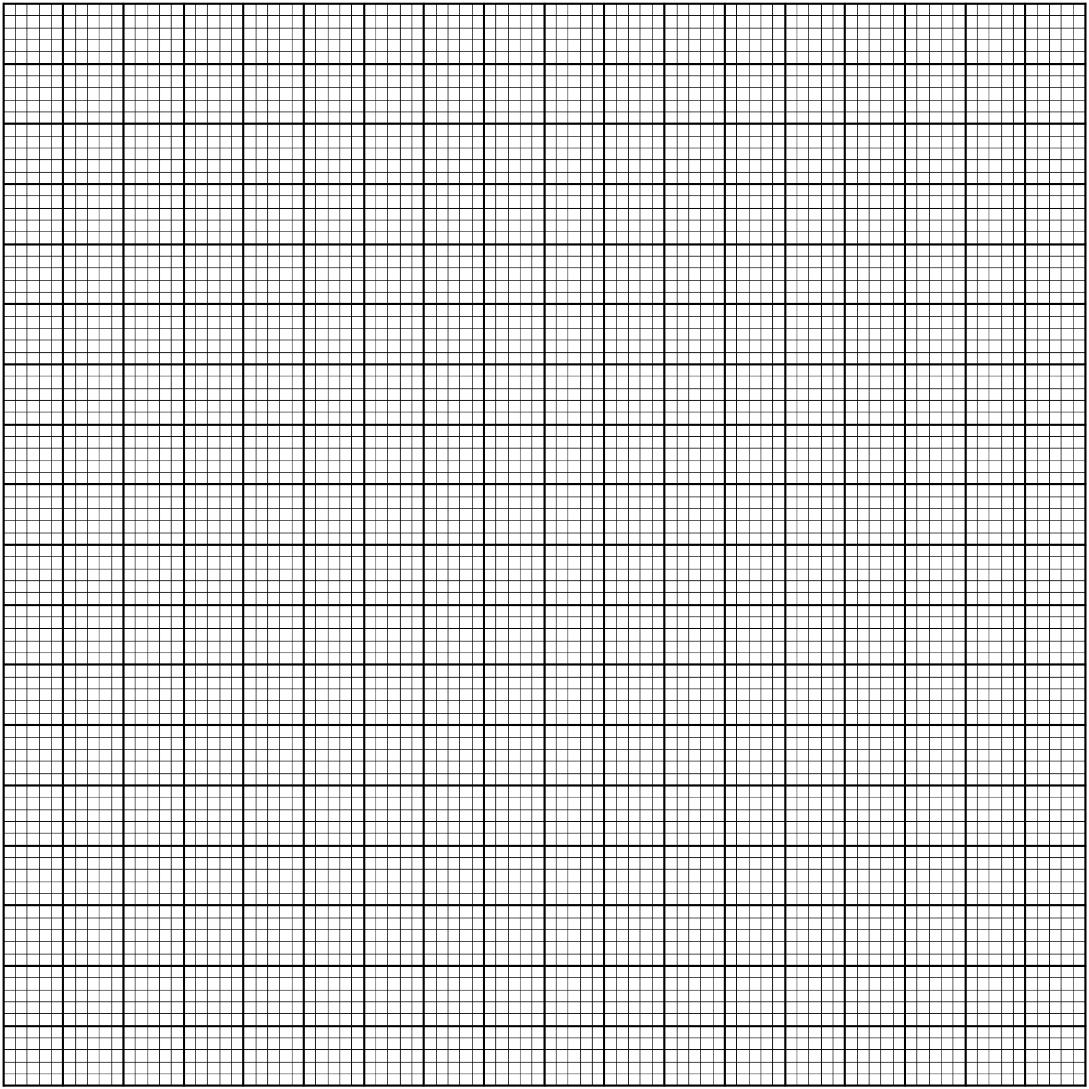

THIS IS THE LAST PRINTED PAGE

