KIRINYAGA CENTRAL SUB-COUNTY EFFECTIVE 40 JOINT EXAMINATION
443/2
AGRICULTURE PAPER 2
JULY/AUGUST 2023 TIME: 2HRS
SECTION A 30 MKS ( Answer all questions in this section)
- Name four dual purpose breeds of cattle ( 2mks)
- Name four mechanical methods of controlling tick (2mks)
- Name four diseases (dis-orders) resulting from mineral imbalances in livestock (2mks)
- State three methods of selection in livestock breeding
2
- Name two breeds of pigs kept for production of pork (1mk)
- State four ways of administering vaccines to livestock ( 2mks)
- Mention four reasons for treating timber before rooﬁng farm buildings (2mks)
- Name two diseases in cattle controlled by the same vaccine (1mk)
- Name the hormones responsible for the following
- Initiating Lactogenesis
2
- Milk let down
- Hindrance of milk let down
- Give four conditions that reduce the quality of eggs for incubation (2mks)
- Give two advantages of two stroke cycle engine of a tractor (1mk)
- Under what two conditions would a farmer prefer to use a cart than a trailer (1mk)
- State four cultural uses of livestock (2mks)
- Name two larval develoomental stages of liverﬂuke that occur outside the intermediate host (1mk)
- State two advantages of using stones as building materials (1mk)
- State four reasons for breeding (2mks)
- Why are eggs packed in trays with their broad end facing upwards (1mk)
- List four tools used laying concrete blocks when constructing a wall (2mks)
- State four factors that inﬂuence the amount of feed in animal consumes (2mks)
SECTION B (20Mks) Answer all Questions in this section)
- The diagrams below illustrate farm tools and equipment . Study them and answer the questions that follows.
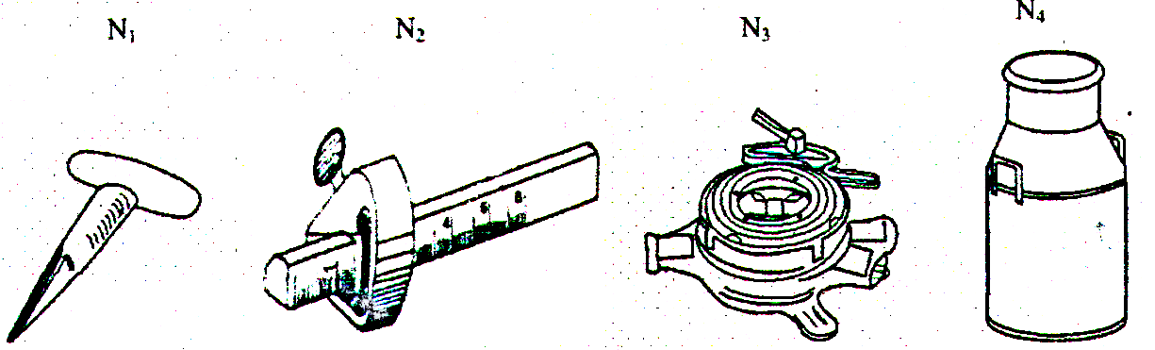

(a) Identify the tools and equipment labelled above (2mks)
b) Classify the above shown tools and equipment under (2mks)
- Garden tools an equipment
- Workshop tools equipment
- Plumbing tools and equipment
- Livestock production tools and equipment
c ) State the function of the tool labelled H2(1mk)
- The diagram below shows a certain practice carried out on cattle
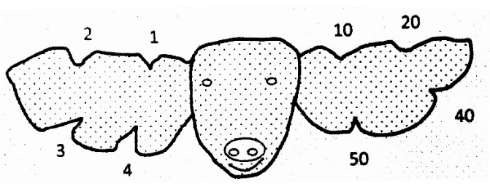

- Identify the practice illustrated above (1mk)
- Draw another illustration depicting cattle number 37 (1mK)
c ) `Name the tool used to carry out the practice illustrated above (1mk)
(d) State two other methods of identifying the cattle ( 2mks)
- The illustration below shows part of the digestive system of a cow. Study it carefully and answer the questions that follows
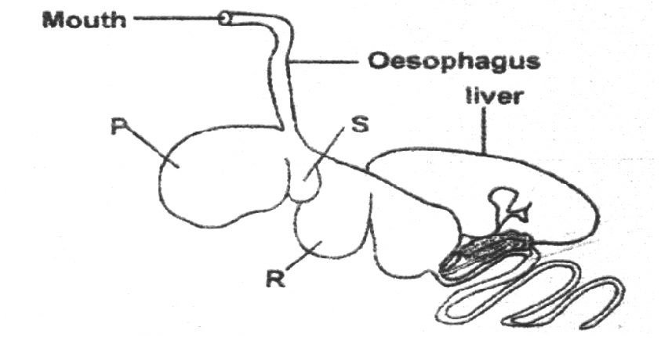

a) Identify the part labelled R on the diagram (1mk)
(b) Which of the part labelled is also referred to as
(I)The “book or many plies “ (1mk)
(ii) The ‘honey comb” (1mk )
( c ) State two microbial activities that take place in the chamber labelled P (2mks)
(d) State the role of oesophageal groove in ruminants (1mk )
23. The diagrams below shows some farm operations. Study it carefully and answer the questions that follows .

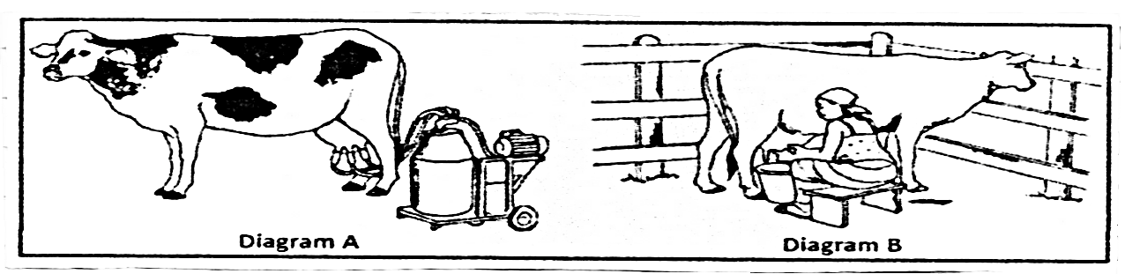
- (i) Identify the operation in photograph A (1mk)
(ii) State one advantage of A over B ( 1mk)
b(i) What activity is being carried out in diagram B (1mk)
- Give two activities carried out on the animal before the above operation in b(I)
2

SECTION C 40 MARKS
Answer any two questions in this section

24(a) Discuss East coast fever disease under the following sub-headings
  - Causal organism (1mk)
  - Name the vector that transmit the disease (1mk)
  - Symptoms of attack (5mks)
  - Control measure and treatment (3mks)
- (b) State ﬁve advantages of live fences (5mks)
( c ) Describe the life cycle of a two host tick (5mks)
25(a) State ﬁve advantages of battery cage system (5mks)
- Describe the power transmission system under the following units
- Clutch (2mks)
- Gear box (2mks)
- Differential (2mks)
(v) Final drive (2mks)
- ( c ) Discuss seven advantages of artiﬁcial insemination (7mks)
- (a) Describe four predisposing factors of livestock diseases (8mks)
(b) State ﬁve differences between a mouldboard plough and a disc plough (5mks)
26 (c) Give seven reason why bees swarm (7mks)

EFFECTIVE FORTY EXAMS AGRICULTURE MARKING SCHEME PAPER 2 SECTION A (30MKS)
1. Sahiwal Red poll
8. Black quarter / Black leg Anthrax (1/ x 1= (1mk)
Simmental
Brown swiss (1/ x 4 = (2mks)
- - Burning infested pastures
- Hand picking the tick and killing it
- Double fencing of the pasture land and farm
- Starving the tick to death by practising rotational grazing
- Interfering with the tick environment by ploughing pasture land or top dressing pasture with lime.
- Anaemia in piglets
- Curved toe paralysis in poultry
- Milk fever in lactating dairy animals
- Goitre in young calves
- (i) Prolactin
- Oxytocin
- Adrenalin
- - Small size / overweight / low weight
- Abnormal shape
- Long storage /poor storage
- Broken shell/irregular shape/Rough shell
- Presence of internal abnormalities like double york , meat spots and other poor candling qualine
- - They are not expensive to buy and maintain
- They are economical in fuel consumption
- They can be used in a wider range of farm land including hilly areas
- They can do small tasks within the farm since it is economical
- - Limited Capital
- When the land is steep
- If the farmer has little load to carry
- - Used as medium of exchange
- Used in social ceremonies
- Used in recreational activities
- Status symbol
- Enzootic ataxia or swayback in lambs
- Mirracidium
Metacercaria (1/ x 2= (1 mk)
- Osteomalaria Bonne ketosis or acetonemia
- Grass tetany or grass stagger or hypomagnicemia
- Parakeratosis (1/ x 4 = (2mks)
- Durable
- Resistant to ﬁre
- Resistant to weather elements
- Resistant to insect damage and rotting
- Mass sekection Progeny testing
Contemporary comparision

- Large white Essex saddle back
Wessex saddle back
- - By injections
- Orally through the mouth
- Through the cloaca
- By inhalation through the nose
- - Prevent attack by insects and fungi
- To resist elements of weather
- To make it durable and more strong
- To resist water penetration
- - To expand the inherited potential of the animal
- Satisfy the consumer’s taste
- For economic reasons
- Overcome production problems created by the environment
- Introduce new genes making the animal better in production
- In order to maintain gaseous exchange since their brilliant end contains the air space
- - Spirit level
- Plumb bob /plumb line
- Masoris square / tape measure / meter rule
- Wood ﬂoat / steel ﬂoat
- Mason’s trowel
- Mason’s hammer / Brick hammer

- Body size or weight of the animal
- Environmental conditions within which the animal is
- level of production
- Purpose for which the animal is kept
- Physiological conditions within which the animal is

SECTION B (20MKS)
- (a) N1- Dibber N2- Marking gauge N3- Stock and die
N4- Milk chum / can
(b 20. (a) N1- Dibber N2- Marking gauge N3- Stock and die
N4- Milk chum / can
2
( c ) It is used for making one marking line which is parallel to the edge of the wood metal
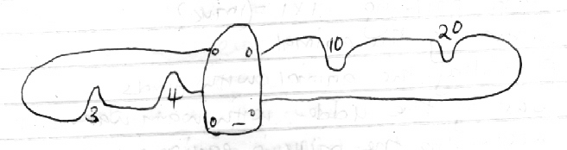

c ) Ear notcher ( 1x1= (1mk)
(d) Branding Ear tagging
Use of neck strap and chain 2 x1 = (2mks)
22(a) R - Omasum ( 1x1=(1mk)
(b) (I)R (ii) S 2 x 1 = (2mks) ( c ) Fermentation of food
- Synthesis of vitamin B complex and vitamin K
- Synthesis of amino acids from ammonia gas
- Breakdown of proteins to peptides amino acids and ammonia
- Breakdown of carbohydrates and cellulose to carbon (iv) oxide and volatile fatty acids
d) Allow movement of food from the mouth to the reticulum ( 1 x 1 = 1mk)
- (a) (i) Machine milking 1 x 1 = (1mk)
(ii) It is faster hence can be used on large scale
b(i) Hand milking 1 x 1 = (1mk)
(ii) Restraining the animal
- Providing the animal with feeds
- Washing the udder with warm water
- Assembling the milking equipment
- Wiping the udder dry
- Testing for mastitis 2x1 = (2mks)

SECTION C 40 MARKS
- (a) (i) Theivelia parra (1mk)
- Brown ear tick (1mk)
- - High temperature
- Coughing
- Sight impairment
- Profuse salivation
- Swollen lymph nodes around the base of ears , shoulders and
stiﬂe joints
- Haemowhages in vulva and the mouth
- Iachrimation (tears comes out of the eyes)
- Profuse salivation ( max 5 mks)
- Controlling of ticks with appropriate methods
- Double fencing to keep away strange animals and conﬁne animals within
- Treatment using appropriate drugs (3mks)
(b) - Cheap and easy to establish
  - Tall varieties act as wind breaks e.g kei apple
  - Have aesthetic value
  - Their roots hold the soil ﬁrmly thus controlling soil erosion
  - Some species act as livestock feed
  - Provide shade to livestock
  - Some species have medicinal value
  - Thorny species are effective in preventing intruders
  - Act as source of organic matter and wood when trimmed ( max 5mks)
c ) Eggs on the ground hatch into larvae which climb onto the ﬁrst host. The larvae
feed on blood become engorged and moult into nymphs , The emerging nymphs feed on the same host, become engaged and then drop to the ground to mount . When the adults emerge they ﬁnd a new host on which they feed on it and mate before the females drop off to the ground to lay egg and the life cycle starts all over again ( max 5 mks)
- (a) - Higher egg production due to less energy wastage by birds
  - Cannibalism and egg eating are controlled
  - Low labour requirement
  - No bullying during feeding
  - It is easy to mechanise
  - Birds no not contaminate food and water
  - Eggs are clean because hens do not step on them
  - Higher stocking rate is allowed
  - One can keep accurate egg records
  - Discourages broodiness
  - Easy to handle birds
  - It is easy to defect sick birds and isolate them for treatment ( max 5mks)
(b) (i) Clutch
  - It connect and disconnect the drive shaft to or from the engine respectively It enables the tractor to take off gradually and smoothly . It also helps to provide power from th engine to the power take off shaft (2mks)
  - Gear box
  - It provides different towards speed . It also allows the driver select any forward on reverse gear to suit operation .
  - It can also allow change in the speed ration by altering the gears conveniently in the gear box
  - It also allows the driver to stop the tractor without suddenly stopping the engine (5mks)
  - Differential
  - It allows changes in direction of the drive to right angles so that power is transmitted to the rear wheels
  - It also enables the rear wheels to travel faster or slower than the other especially when negotiating a corner
  - Differential lock avoids the skidding ( 2mks)
  - Final drive
This is where the wheels propel the tractor machine either forward or backward enabling the tractor to more and do useful work . At the same time the tyres allows maximum grip which is also called traction ( 2mks)
c ) Helps to control breeding disease and parasites
- Prevent large bulls injuring small cows
- Reduces the expenses of keeping a bull
- Semen can be stored for a long time even after the death of a bull
- Controls breeding
- Controls inbreeding
- Eliminates dangerous bulls from the farm
- Useful research tool
- Semen of one superior bull can be used to serve many cows
- Small scale farmer who cannot afford to buy a superior bull can have the cows served at a very low cost ( max 7mks)
26(a) Species of the animal- This determines the type of disease that is likely to affect that species
and not any other e.g swine fever affects only pigs and new castle disease affects only poultry
- Breed of the animal - inﬂuences the kind of disease that will affect a particular breed of animal
e.g cancer of the eye only affect hereford breed of cattle only
- Age of animal- certain disease are associated with animals of a certain age group e.g. piglet anaemia affect only piglets
- Sex of animal - certain diseases are associated with the sex of the animal due to different structures of various organs in the two sexes e.g vaginitis affects only female animals as it is a disease of the vagina.
- Colour of animal - Animals which are black in colour are likely to suffer from heat stress
- Overcrowding
- Environment - Dirty and ﬁlthy environment predisposes animal to diseases
- Herredity- those diseases that are inherited
- Physiological conditions e/g fatigue, pregnancy may predispose an animal to diseases
4 x 2 = (8mks) mark ﬁrst four points

( c ) Overcrowding
- Sick or infertile queen
- Dampness and bad smells
- Lack of adequate ventilation
- Damage of blood combs
- Outbreak of diseases and parasites
- Shortage of food and water in the surrounding ( 7mks)

26 (b) Mould board plough | disc plough
- Requires more tractor  power to pull when operating  - It is rigid hence easily broken by obstacles  - Operates at a uniform depth  - fewer secondary operations are needed  - Invert furrow slices completely  - It is rigid hence cannot be used on a ﬁeld with obstacles | - Requires less power to pull when operating  - It is not easily broken by obstacles  - Cuts at a varying depth  - More secondary operations are necessary  - Does not invent the farrow slices completely  - Does not invert the farrow slices completely  - Can be used on a ﬁeld with obstacles because the disc rolles over them

