KIRINYAGA CENTRAL SUB-COUNTY FORM 4 EXAMINATION
443/1
AGRICULTURE
PAPER 1
SECTION A ( 30marks)
- Give three branches of horticulture .
- State two systems of farming which are used in Kenya ( 1mks)
- List down four aspects of rainfall that affect agriculture (2mks)
- List three main ways in which pasture crops can be classiﬁed
- State two effects of early defoliation (1mk)
- State three properties of soil that are inﬂuenced by soil texture
- State the importance of each of the following ingredients in the preparation of manure
- Woodash (1mk)
- Top soil (1mk)
- (a) Name the vegetative part of each of the following crops which is propagated
- Sweet potatoes
- Cassava
- Bananas
- Oranges
(b) Give three problems farmers face when marketing vegetables
- A certain fertiliser has the following characteristics: Was greyish in colour;
Highly hygroscopic;
When tested it has a neutral PH
- Name the fertiliser described above
- State the time of application of the fertiliser named in (i) above
- Identify three natural factors that inﬂuence soil erosion
- Name three types of land which may require reclamation
- State three types of surface irrigation in crop production
. Give a cause of forking in carrot production
- There is a maize variety given as H612. What do the letter H and number 6 in the letter H and number 6 in this variety stands for?
- Outline two features of a sorghum crop that makes it drought resistant
16, Name two varieties of Napier grass
17. Name three sources of underground water
18(a). State three forms of agroforestry
(b) Give any two forms of collective land tenure systems

Name a weed that;
- Is poisonous to livestock
- Taints milk
- Give any four factors that affect efﬁciency of a pesticide (2mks)

SECTION B (20 MARKS)
Answer all questions in this section
- The following is a pruned crop. Study it carefully and answer the question that follows.

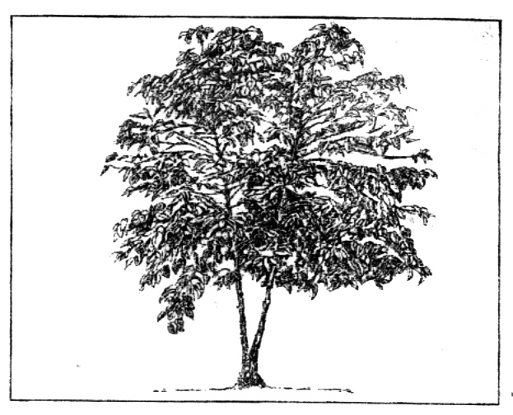
- Identify the method of pruning (1mk)
- Give two disadvantages of using the above method of pruning (2mks)
- Apart from the above method, give any other method of pruning coffee (1mk)
- Name the part harvested in coffee (1mk)
- The diagram below shows a method of crop propagation . Study it and answer the questions that follow.

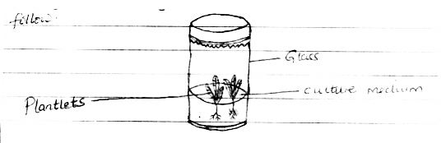
Culture medium
- Identify the method (1mk)
- Name two crops that can be propagated using this method (2mks)
- Give two ingredients used when preparing the culture above (2mks)
- The diagram below shows a storage building for a cereal crop

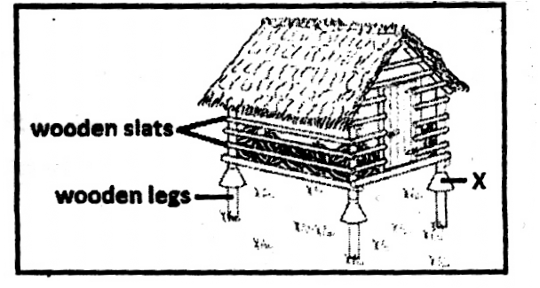

- What is the purpose of the part labelled X (1mk)
- The roof is thatched . State a possible disadvantage of the thatched roof (1mk)
( c ) State any three structural requirements of a good grain store (3mks)
- Below shows a format of a farm record. Use it to answer the questions that follows.

DATE DISEASE DRUG COST OF REMARKS SYMPTOM USED TREATMENT
- Name the farm record illustrated (1mk)
- Give four uses of the forum record shown above (4mks)

SECTION C (40 Marks)
Answer two questions from this section
- (a) Describe the process of silage making (10mks)
(b) Explain ﬁve factors that inﬂuence spacing of crops (5mks)
c) Describe five factors that may increase the demand of a commodity even when price of the commodity is unchanged
- (a) Explain ﬁve environmental factors that inﬂuence the efﬁciency of a herbicide (5mks)
(b) Outline ﬁve advantages of Landlordism and tenancy systems of land ownership (5mks)
(c) Describe the procedure of transplanting a containerised tree seedling (6mks)
(d) Outline any four factors considered when drawing up a farm plan. (4mks)
- (a) Describe any eight cultural measures that are used in soil and water conservation (8mks)
(b) Describe the procedure of harvesting coffee (5mks)
(c) Outline any four beneﬁts of growing crops under optimum temperature (4mks)
(d) State any three government policies that improve agricultural production (3mks)

KIRINYAGA CENTRAL

443/1
AGRICULTURE PAPER ONE
MARKING SCHEME

SECTION A (30MARKS)
- Three branches of horticulture
Pomoculture / Pomology
Vines ; root tubers
- Cassava
Stem cuttings
Floriculture
Olerculture/ Viticulture

Two systems of farming in Agricultural Production
Extensive Farming
Intensive Farming

Aspects of rainfall that affect agricultural Production
Rainfall Amount
Rainfall distribution / Rainfall pattern Rainfall intensity
Rainfall Reliability
4, Ways of classifying Pastures Based on altitude where they grow Based on pasture establishment
Based on Pasture stand
- Effects of early defoliation Pasture has high moisture content Pasture has low crude protein yield Pasture has low dry matter yield Pasture is low on digestible nutrients
There is gradual weakening of the pasture stand leaving empty patches which get invaded by weeds

Properties of soil inﬂuenced by soil texture
Soil capilarity Soil drainage
Water holding capacity

Importance of each of these ingredients in the preparation of manure
- Woodash
Improves the level of phosphorus and potassium in the resulting manure (1mk)
- Bananas Suckers
- Oranges
Bud; Buddlings
2

Problems vegetable farmers face when marketing their produce
- Oversupply of vegetables during the rainy season ; this reduces the prices thus reducing farmers proﬁt
- Poor roads in rural areas where vegetables are produced making it difﬁcult to transport vegetables to the market
- Vegetables are perishable thus loses quality very fast
- Vegetables are bulky so posses a difﬁculty in transporting them to market
- Lack of market information about where to sell their vegetables
- Poor extension services ; Farmers do not get training on new vegetables farming techniques
- Low prices offered to farmers thus demotivating them
- (i) Fertiliser that is grey in colour and has a neutral PH
Calcium Ammonium Nitrate rej: CAN
(ii) Time of application of CAN
During topdressing when crops emerge from soil

Natural factors that inﬂuence soil erosion
Intensity of rain
Slope of land / Length of the slope Soil depth
Soil type
Vegetation cover / Ground cover
(b) Top soil
Introduces micro-organisms necessary for the decomposition of organic manure (1mk)
8(a) Vegetative parts used in propagating these crops
- Land that may require reclamation Swampy / marshy ﬁelds
Steep / Hilly lands Eroded / Gullied areas
Arid and semi-arid ( ASAL) lands
Tsetse ﬂy infested areas

SECTION B ( 20 Marks)

Types of surface irrigation
Furrow irrigation Flood irrigation
21. (i) The coffee pruning method
Multiple stem pruning (1mk)

(ii) Disadvantages of multiple stem prunin
Basin irrigation ( Any 3 x
Difﬁculty in gatherings berries from top

Causes of forking in carrot production
Organic manures
Presence of obstacles in the soil eg sticks and stones

Variety H612
H - Hybrid
6 - Altitude where the variety grows in thousand feet above sea level

Features of sorghum crop that makes it drought resistance
Ability to roll its leaves when the weather is hot An extensive root system to draw water from far surface

Varieties of Napier grass
Bana grass
French Cameroon
- Sources of underground water Wells
Springs
Boreholes
18(a). Forms of Agroforestry Agrosilviculture
Silvopastoral
Agrosilvopastoral
b) Forms of Collective Land Tenure Systems Communal tenure
Co-operative tenure
State Ownership
Rotting of stems with age
Frequent breaking of stems and branches Difﬁculty in spraying tall bushes (Any 2x1=2mks)

Any other method of pruning coffee
Single stem pruning (1mk)
- Part harvested in coffee
Berry / Cherry Accept Plurals ( 1mk)
22. (a) Method of crop Propagation
- Tissue culture (1mk)
- Crops propagated through tissue culture Bananas
Passion fruits ( 2 x 1 = 2mks)

Ingredients used in preparing the rooting medium
Sugar
Inorganic Minerals Vitamins
Organic Supplements
Growth regulators / hormones ( Any 2 x 1 = 2mks)
23 a) Function of the rat guard ( part x) Prevents rats / vermin from climbing up the store (1mk)

Disadvantage of a thatched roof
Harbors pests Not durable
Can catch ﬁre easily
Causes dampness in the store ( Any 1 1 = 1mk)

Structural requirements of a good grain store
- A weed that is,
- Poisonous to livestock
Thorn apple/ Datura stramonium Sodom apple / Solanum Incanum

Taints milk
Mexican Marigold / Tagetes Minuta

Factors that affect efﬁciency of a pesticide
Pesticide concentration
Weather conditions during and slightly after application
Persistence of the pestcide
Time of application of the pesticide
Vermin / rat proof Easy to clean
Easy to load and ofﬂoad Have a leak - Proof roof
Well ventilated to keep the grains fresh ( Any 3x1=3mks)
24(a) Type of farms record illustrated Health record (1mk)
(b) Uses of a health record
Selection of a breeding stock
Culling of stock based on health history Determination of treatment costs
Resistance by the pest
Shows prevalent diseases in the area
Tracing history of a disease for effective treatment Shows schedule for routine practices e.g Vaccination

SECTION C ( 40 Marks )
25.(a) The process of silage making
- Prepare the desired silo
- Cut the crop at the ﬂowering stage when it has maximum nutrients
- Wilt the cut crop for 6-12 hours
- Chop the wilted crop into small pieces (using either a panga or chaff cutter or a forage harvester)
- Fill the chopped crop into the silo compacting at every 10-12 cm layer formation
- Fill the silo rapidly within one day
- Maintain the temperature of the soil at 32-2⁰c during ensiling.
- The material should have a humped appearance /ridge appearance after ﬁlling up with the highest part of the ridge being at the centre .
- Cover the material with a polythene sheet at dry grass to protect it from the water and air.
- Cover the soil with a thick layer of soil maintaining the humped appearance .
- Dig a trench round the soil to drain away the rain water. (10x1=10mks) stop marking where the product is broken

(b) Factors that inﬂuence spacing of crops
- Use the crop / purpose for which crops is grown, a crop to be used as fodder is closely spaced. That for grain production is widely spaced.
- Size of crop at maturity; Tall crop varieties are widely spaced. Dwarf varieties are closely spaced
- Growth habit of the crop ; tillering varieties / spreading varieties are widely spaced - Those with erect type are closely spaced
their purchasing power.
- An increase in consumers income which increases their purchasing power
- An increase in population which increases the number of consumers .
- If the tastes and preferences of consumer change into liking of a particular commodity
- Consumers expectations of a price increase of the commodity in the future.
- Much advertisement of the commodity making the consumers aware of the availability of the particular commodity in the market .
- Climate / weather; fro instance cool weather may increase the demand for woolen clothes

26.(a) Environmental factors that inﬂuence efﬁciency of a herbicide
- Wind ; May drift the chemical from the intended plant lowering its concentration and so its efﬁciency
. Rainfall; May either wash away or dilute the chemical from the intended plant reducing it efﬁciency .
- Light Intensity : High light intensity increases physiological process such as photosynthesis and respiration hence optimises herbicide uptake.
Soil ; Moist soils soak the herbicide and retain it for long increasing its effects on weeds.
Temperature: Optimum temperature ensures weeds are physiologically active hence more herbicide uptake.
- Again low temperature minimizes herbicide evaporation increasing its efﬁciency on weeds
- Soil fertility ; A fertile soil can support a large plant populations hence a closer spacing is adapted .
- Moisture availability / Rainfall pattern of the area; wet soil can support a larger plant population hence a closer spacing is adapted .
- Machinery can be used ; where farm operations are to be done using machines, then a wider spacing is used

(c) Factors that may increase demand at particular commodity
- An increase in the price of a substitute / good that serve a similar purpose
- An increase in consumers income which increases

(b) Advantages of Landlordism and Tenancy Tenure
- Idle land is put into use by tenants hence increasing agriculture production
- Land lords who for certain reasons cannot work on their land get income through renting .
- People without land can rent land and earn a living
- Land disputes are reduced because the running of the land is the responsibility of the landlord
- Ensures equitable distribution of land as a natural resources ( Any 5 x 1= 5mks)

(c ) Procedure of transplanting a containerised tree nursery
- Transplanting holes are dug in the seed at appropriate spacing for the speciﬁc tree species
- While digging the hole, top soil is heaped separately from the sub soil . It is in reﬁlling the hole halfway
- Top soil is mixed with manure
- Transplanting is done at the criset of long rains to give the seedling a start
- The seedling is watered generously to make the soil stick long either and also to ease the removal of the polythene sleeve during transplanting for seedlings raised in sleeves .
- Slit the sleeves length wise using a knife . Then open and remove the seedling from the container
- The seedling is placed at the centre of the transplanting hole
- The seedling is covered with soil up to the rot cellar / up to the depth it was in the nursery .
- Soil is ﬁrmed around the seedling
- The seedling is then watered, mulched , then provided with a temporary shade is conserve moisture .
- After transplanting young trees may be protected from damage by animals by either fencing the ﬁeld or erecting ticks round the individual tree.

Factors considered when drawing up a farm plan
- Size of the farm ; A large farm can accomodate more enterprise
- Ecological conditions of an area ; select enterprises that are favoured by the soil , rainfall , topography of the area .
- Availability of capital; To acquire inputs
- Government policies ; Avoid enterprises prohibited by the government or seek permission from government authories for enterprises established through quota system.
- Availability and costs of inputs ; select enterprises whose inputs are available and affordable .
- Current labour trends; To ensure labour is available and especially during the peak periods
- Prices of output ; Select enterprises that are marketable and whose products have ready market
Tastes and preferences / farmer’s whip so that farmer may own up the plan ( Any 4 x 1 = 4mks)

27 (a) Describe any eight cultural measures that are used in soil and water conservation
- Gross strips / Filter strips; To reduce the speed of run off, and for the grass to ﬁlter / trap the soil contained in the run-off water
- Cover cropping; cover crops prevents baking of soil by the sun .
Reduces impacts of rain drops thus reducing splash erosion
Reduce the spread of run-off water traps the soil in the run-off
- Grassed / vegetated waterways; Slow down the speed of run-off water
Grass trap the eroded soil carried by the running water
- Contour farming; Created ridges of earth which had water thereby increasing water inﬁltration into the soil
Mulching; Reduces impacts of raindrops on soil thus reducing splash erosion .
Organic mulches upon decomposition release humus which improve on soil structure reducing erodibility of the soil .
Mulches cover the soil protecting it from wind erosion
- Strip cropping ; Different strips of crops reduces speed of runoff water hence improving inﬁltration Crops ﬁlter soil .
Crops are harvested at different times so that there is a strip of crops in the ﬁeld at any time . This avoids a bare land .

Afforestation / Reafforestation
Tree canopy protects soil from wind that would detach and remove soil particles .
Tree canopy intencept rain drops reducing raindrops erosion .
Tree roots stabilizes soil reducing its erodobility . Crop rotation ; Inclusion of grassleys in the rotation programme maintains a soil cover for protection against erosion
Correct spacing of crops; Ensures adequate ground cover

