GEOGRAPHY 312/1
MARKING SCHEME
SECTION A (25 MARKS)
Answer all the questions in this section in the spaces provided
1. (a) Define the term International date line (2marks)
- This is the line running from the North Pole to the South Pole, along the 180° meridian in the Pacific Ocean that separates one day from the other.
(b) State two effects of international date line (2marks)
  - When one crosses to the east, one losses a day.
  - When one crosses to the west, one gains a day.
2. (a) Distinguish between absolute and relative humidity (2marks)
- Absolute humidity is actual amount of water vapour present in air at any given time while relative humidity is the available water vapour in the air compared to the maximum water vapour air can hold at the same temperature.
(b) Name two isothermal layers of the atmosphere (2marks)
- Tropopause
- Mesopause
- Stratopuase
3. (a) State three reasons why tundra region has scanty vegetation (3marks)
- The ground is frozen most of the year.
- The area has short growing seasons
- The region has thin soils that are not able to support vegetation.
- Some parts of the region are poorly drained.
(b) State four characteristics of Mediterranean type of vegetation (4marks)
- Some trees are deciduous
- Some plants small/spiky/thick skinned leaves
- Some plants are evergreen
- Some plants have large fleshy bulbous roots
- Some plants have long taproots
- Grasses dry off during summer and sprout in winter
- Some plants have thick barks
4. (a) What is Isostasy (2marks)
- State of balance that exist between sima and sial
(b) Describe the characteristics of subduction zone (3marks)
- Plates move towards each other
- Earthquakes may be experienced
- Existing rocks may be destroyed
- Fold mountains maybe formed
5. The diagram below represents a depositional feature in a glaciated landscape. Use it to answer the questions that follow.

DIRECTION OF ICE
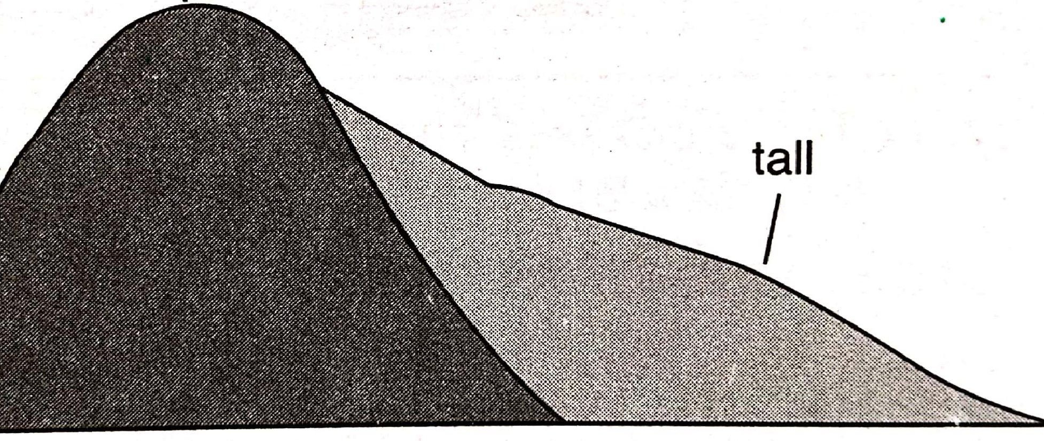

(a)Identify the feature above. (1mark)
- Crag and tail
(b) Describe how the above feature is formed. (4marks)
- Large mass of resistant rock protrudes on the path of glacier in a lowland.
- The surrounding rock is eroded faster than the resistant rock
- The upstream slope is eroded by ice through abrasion and plucking making it rugged and steep.
- The ice moves over the resistant rock and soft rock on the downstream forming a gentle slope.
- When ice retreats, the part of the rock forms crag and the soft part on the leeward forms the tail.
- Combination of resistant and soft rock forms crag and tail.
SECTION B (75 MARKS)
Answer questions 6 and any other two questions from this section.
6. (a) (i) Identify two physical features found in grid square 9228 (2marks)

- River
- River valley
- Steep slopes
- Thicket
- Scrub
- Scattered trees
- hill

(ii) Measure the all-weather road loose surface found in the western part of the map. Give your answer in kilometers. (2marks)
- 5.7km
(b) (i) Give three types of vegetation found in north of Northing 36 and east of Easting 91 covered by map. (3marks)

- thicket
- scattered trees
- woodland
- scrub

(ii) Draw a rectangle measuring 12cm by 8cm to represent area enclosed by Easting 87 and 90 between Northing 36 and 38. (1mark)
On it mark and label
- Thicket (1mark)
- Dry weather road (1mark)
- Escarpment (1mark)
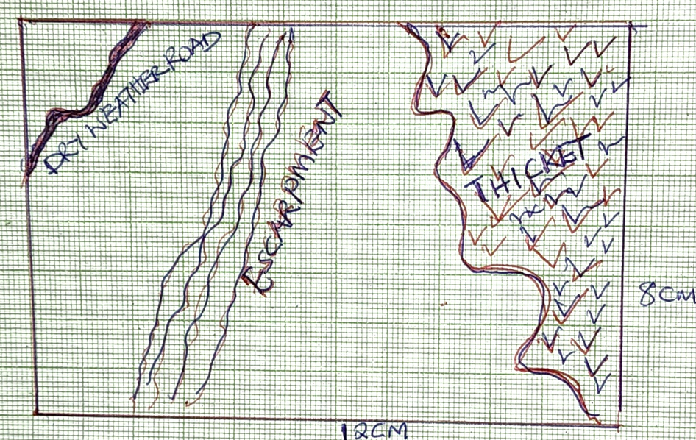

(iii) Calculate the new scale (2marks)
- 1:100000
(c) (ii)Describe the distribution of natural vegetation of area covered by the map. (6marks)
- There is forest vegetation on the southern part of part of the map/Tingwa hill/western part
- There is thicket vegetation around Tingwa hill forest/central part/southern part
- There is woodland vegetation around kipkabus forest/keiyo escarpment
- Scrub vegetation on the eastern part of the map
- There is bamboo vegetation within Tingwa hill forest
- Scattered trees on the eastern part of the map
- There are papyrus swamp vegetation on the western part of the map
(iii) Explain how drainage has influenced settlement on the area covered by the map(6marks)
- There are no settlements around the seasonal swamps due to fear of flooding/water borne diseases
- There are many settlements around dam in grid square 8038 due to access of water for use.
- There are linear settlements along some rivers due to access of water for use
- There are few settlements along some rivers due fear of floods
7. The diagram below shows a glaciated area, use it to answer question
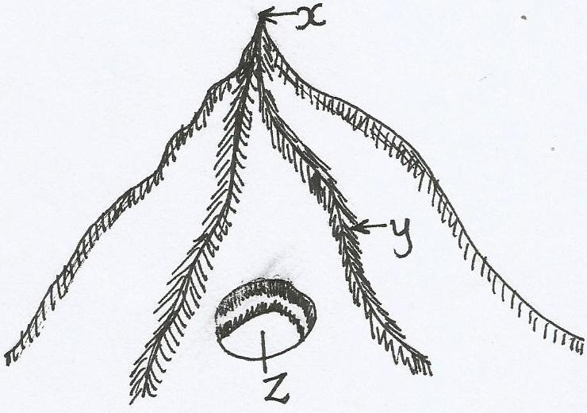

(a) (i) Name the features marked x,y and z (3marks)
X-pyramidal peak
Y-Arete
Z-Cirque/corrie
(ii) State three reasons why there is a reduction in the amount of glacial cover over the
Earths surface (3marks)
- Rising of surface temperature
- Accumulation of soot on ice makes the ice to melt
- Reduced snowfall due to climate change
(b) (i) Describe how a tarn is formed (6marks)
- Snow accumulates in a pre-existing depression on a mountain side.
- The snow gets compacted to form a cirque glacier.
- The accumulated ice erodes the hollow by plucking and abrasion making it deeper and wider.
- Eventually an arm-chair shaped depression known as a cirque is formed.
- The depression is filled with melt water to form a tarn.
(ii) Explain three positive effects of glaciation (6marks)
- Glacial till provide fertile soils for farming
- Outwash plains comprise sand which can be used in building and construction.
- Glaciated features such as pyramidal peaks attract tourists
- Glacial lakes provide water for domestic and industrial use.
- The scouring effect of ice sheet expose mineral seams making it easy to exploit.
- Waterfalls from hanging valleys can be harnessed to produce HEP.
- Fiords act as breeding ground for fishing thus influencing fishing
- U-shaped valleys act as natural route ways/suitable for livestock keeping
(c) You are required to carry out field work in a glaciated area
(i) Give three methods you will use in data collection (3marks)

- Administering questionnaires
- Experimentation
- Observation
- Conducting interviews/ interviewing
- Taking measurement
- Sampling
- Content analysis
- Taking photographs

(ii) What problems are you likely to encounter (2marks)
- snow fall making data collection difficult
- sliding off from the glacier/accidents
- inaccessibility of some areas
- attack by wild animals
(iii) What are some follow-up activities you would do (2marks)

- Report writing
- Reading more on the topic
- Group discussion
- Displaying photos/samples
- Playing videos

8. (a) State three factors that contribute to development of deserts (3marks)
- prolonged droughts/low rainfall
- increased temperature/excessive/ evaporation
- existence of cold ocean currents
- human activities/deforestation
- continentality
(b) (i)Explain three process of wind transportation. (6marks)
- suspension-fine dust particles are lifted off the ground and blown over long distance.
- Saltation-medium size particles are lifted from ground by eddy currents in series of hops and jumps
- Traction-heavy materials are dragged on the ground by the currents
(ii) Using well labeled diagrams, describe how a barchan is formed. (7marks)
- sand laden wind encounters an obstacle along its path
- sand begins to accumulate around the obstacle
- the gradual accumulation of sand forms a hill.
- Eddy currents on the leeward side causes formation of a shallow depression/concave/steep slope.
- With time, the prevailing wind forces the sand at the edge to move forward, forming horns
- Eventually, a crescent shape feature called a barchan is formed
(c) Form three students wanted to carryout field study on desert landscape.
(i) State two hypothesis for their study (2marks)
- The features formed in the desert are not beneficial to man
- Sand from deserts are harvested for construction
- Depressions in the deserts have water.
- ANY OTHER RELEVANT THAT HAS NULL AND ALTERNATIVE HYPOTHESIS
(ii) Give two methods of data recording they would use (2marks)

- Field sketching
- Mapping
- Tabulation
- Tallying
- Note taking
- Tape recording
- Taking photographs
- Labeling samples
- Filling in questionnaires

(iii) Identify three water erosional features they are likely to observe (3marks)

- Messas
- Buttes
- Inselbergs
- Gorges
- Wadis
- Pediments

(iv) State two problems they are likely to encounter during their study (3marks)
- Strong tropical winds
- High temperatures/excess heat/dehydration
- Inaccessibility of some areas
- Attack by wild animals
9. (a) (i) State three causes of ocean currents (3marks)
- Differences in ocean water density or salinity
- Shape of coastal landmass
- Rotation of the earth
- Winds blowing over the ocean water
- Difference in ocean water temperature
(ii) Give three types of islands. (3marks)
- Oceanic islands
- Continental islands
- Coral islands
(b) (i) State three characteristics of emerged highland coasts. (3marks)

- The coasts have raised beaches
- They have raised wave-cut platform
- They have raised cliffs
- They have hanging valleys
- Raised rias

(ii) Explain two factors that influence development of coasts. (4marks)
- Climate of the area-this will determine development of coral coasts in tropical areas
- Nature of coastal rocks- this will either encourage rapid wave erosion or reduce speed of erosion/ Hard rocks result in the formation of cliffs while soft rocks result in the formation of bays/inlets.
- Gradient of the coast-steep coasts encourage formation of cliffs/gently sloping coasts encourage formation of beaches.
- Alignment of the coast- prevailing winds will influence wave erosion/deposition
- Human activities- human activities interfere with natural state and appearance of the coasts
(iii) Using well labled diagrams describe how a bay bar is formed (6marks)
- Long shore drift is halted
- This leads to deposition of materials at the entrance of the bay.
- Spit forms at the entrance of the bay.
- Longshore drift continues to deposit materials and spit extends to the other side of the headland.
- Eventually spit reaches the other end enclosing a lagoon forming a bay bar.
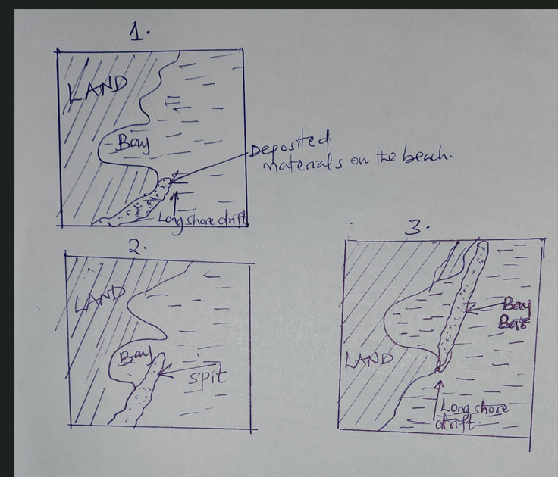

(c) Explain three significance of oceans to human activities (6marks)
- Oceans modify the climate of surrounding land masses which influences various human activities.
- Oceans are a very important field where research is conducted on marine life and configuration of the ocean floor.
- Oceans have been used as bases for launching military attacks.
- Oceans form part of features used to demarcate international boundaries between or among independent countries.
- Oceans provide cheap water transport between continents thus encouraging various economic activities.
- Oceans form beautiful sceneries that attract tourists who bring foreign exchange.
- Water from oceans can be used for domestic and industrial purposes
10. (a) (i) Name two features formed due to river rejuvenation (2marks)
- Knick points
- River terraces
- Incised meanders
- Abandoned meanders
- Rejuvenated gorges
(ii) Explain three processes of river erosion (6marks)
- Solution-soluble minerals in the rocks are dissolved in water and are transported in solution form.
- Abrasion- the load carried by water such as gravels/boulders scratches the river bed and bank thus dislodging the rock particles which are moved downstream.
- Attrition- the load carried by water hit against each other making them smoother and smaller in size.
- Hydraulic action-water enters cracks along the river bed and compresses air thus widening the cracks. As water retreats, pressure is released thus shattering the cracks
(b) (i) Identify any three drainage systems (3marks)
- Accord ant
- Discordant
- Back-tilted
(ii) Using well labeled diagrams, describe how river captures occurs (8marks)
- Two rivers flow adjacent and parallel to one another
- One river is powerful and the other is weak
- The powerful river erodes its valley faster than the weak river since it has more water than the weak river.
- The tributary of the powerful river erodes its valley vertically and headwards towards the valley of the weaker river.
- The tributary of the pirate river flows at a lower level than the weak river.
- Eventually, the tributary of the powerful river joins the valley of the weak river.
- The headwaters of the weaker river begins to flow into the powerful river.
- This is the river capture.
(ii) Explain three negative effects of rivers to man (6marks)
- River water is used for both domestic and industrial purposes.
- Most rivers have fresh water which is suitable for irrigation.
- Navigable rivers or their sections are used as transportation routes in many parts of the world.
- Some rivers provide port facilities especially in their rias and estuaries.
- Some rivers are rich fishing grounds.
- Rivers have been dammed and their water used for the generation of H.E.P.
- River beds and valleys are sources of building materials such as smoothened gravel and sand.
- Some alluvial sediments may contain valuable minerals like gold and diamond.
- Features formed by rivers such as waterfalls are tourist attraction.
- During flooding rivers deposit alluvium in the flood plains and deltas. These has resulted into into fertile soils for agriculture.
- Some rivers form natural boundaries between administration divisions.
- When rivers flood, a lot of property and human life is lost.
- Some rivers are so wide that they form barriers between communities making transport and communication difficult.
- Rivers can be a medium of spreading water- borne diseases such as bilharzias, amoebisis e.t.c.

